Bitcoin
User’s Guide

Understanding The World’s first Digital Currency

by Ryan Venter

“I do think Bitcoin is the first [encrypted money] that has the potential to do something like change the world” - Peter Thiel, Co-Founder of Paypal

“Bitcoin will do to banks what email did to the postal industry” - Rick Falkvinge, Founder of the Swedish pirate party

“Bitcoin actually has the balance and incentives right, and that is why it is starting to take off” - Julian Assange, Founder of WikiLeaks

“Bitcoin is a remarkable cryptographic achievement and the ability to create something that is not duplicable in the digital world has enormous value” - Eric Schmidt, CEO of Google

“I think the fact that within the bitcoin universe an algorithm replaces the functions of [the government] … is actually pretty cool. I am a big fan of Bitcoin” - Al Gore, 45th Vice President of the United States

Table of Contents
Introduction 6
Bitcoin 13
Operator of Bitcoin 15
Creator of Bitcoin 16
Why do Bitcoins Have Value? 18
Bitcoin as a Currency 20
Bitcoin as a Payment System: Resolution the Double-Spend Problem 22
The History of Bitcoin 25
Why Use Bitcoin? 31
The Advantages and Disadvantages of Digital cash 31
How Does Bitcoin Work? 40
Cryptography 41
Cryptographic Hash Functions 41
Merkle Trees 44
Public-key Cryptography 46
Digital Currencies 47
Properties 47
Double-Spending 48
Types of Digital Payment Systems 49
Type 1. Credit/Debit Cards (Properties 1-3) 49
Type 2. Digital money (Properties 1-4) 50
Type 3. Offline Digital money (Properties 1-5) 52
Type 4. Redistributed Digital Currency (Properties 1-3, 6) 53
Millions of Deposit Boxes 53
Mining for Coins 55
A Chain of Blocks 56
Network Verification 57
How to acquire Bitcoins 59
Digital Faucet: Free Coins 60
Sell Your Stuff 60
Purchasing Bitcoins 61
Mining for Bitcoins 65
How to Accept Bitcoin, For Small Businesses 69
Starting to settle Transactions For Bitcoin 69
Avoiding Fraud 71
Setting Prices 72
Contracts 72
Paying Taxes on Bitcoin Gains 75
How to Store Your Bitcoins? 75
Desktop Wallets 75
Mobile Wallets 76
Online Wallets 77
Hardware Wallets 78
Paper Wallets 80
Storing and Securing Your Bitcoin 82
Bitcoin-Qt: The Real Deal 83
Advantages 83
Disadvantages. 84
Modified Wallet Software 84
Accessible Anywhere: Web-Based Wallets 85
Bitcoin on the Go: Mobile Wallets 86
More About Paper Wallets 87
The Threats 88
Yourself 88
Physical Theft: Roommates and “Friends.” 89
Active Attacks: Hacking 90
Passive Attacks: Malware 90
Avoiding The Risks 92
Have a Clean Software Package 92
Acknowledge that the Internet is Dangerous 93
Use 2-Factor Authentication 93
Spending and Accepting Bitcoin 95
The Future of Bitcoin 99
Conclusion 102
Glossary 103

Introduction
There is little doubt that the twenty-first century is the century of information technology, using the internet as its primary catalyst.
There is little doubt that the twenty-first century is the century of information technology, and the internet is the primary catalyst.
The great move online has saved time and money for millions of businesses the world over, keen to streamline profits by leveraging free advertising and instant communication. Merchants have shifted their focus to e-commerce, while info trading, consultation and related services have all seen massive expansion.
The great shift online has saved time and money for millions of businesses the world over, keen on streamlining profits by leveraging free advertising and instant communication. Merchants have shifted their focus to e-commerce, and information trading, consultation and related services have all seen massive expansion.
The old 20th century model of paying for expensive city-center retail staff, billboards and shelf space has fallen from favor. Companies now store their products in cheap warehouses to await direct shipping to today’s eager consumers, who in turn, are fed a constant stream of cut-price product advertisements, direct to their arsenal of tablets, phones and other increasingly affordable mobile devices. Such factors have combined to make 24/7 light-speed commerce not only possible but popular, leading to a growth in web sales that is truly exponential.
The old 20th century model of paying for expensive city-center retail staff, billboards and shelf space has fallen from favor. Companies now store their products in cheap warehouses and await direct shipping to today’s eager consumers, who in turn, are then fed a constant stream of cut-price product advertisements, directly to their arsenal of tablets, phones and other increasingly affordable mobile devices. Such factors have combined to make 24/7 light-speed commerce not only possible but very popular, leading to a growth in web sales that are truly exponential.
But electronic commerce requires electronic finance, and there has been no stopping the rise of online banking either. However, in the wake of growing fees and the 2008 financial crisis, the world has seen an overall loss of confidence in the traditional banking system and even the US dollar itself.
But electronic commerce requires electronic finance, and there has been no stopping the rise of online banking either. However, in the wake of ever growing fees and the 2008 financial crisis, the world has seen an overall loss of confidence in the traditional banking system and even the US dollar itself. The Bitcoin White Paper from Satoshi Nagamoto mentions these concerns in the introduction.
That recession greatly influenced people’s view of the dollar as the world’s reserve currency, not only at the consumer level but among governments and market traders alike. It became a common expectation on global markets that the dollar and those national currencies pegged to it were certain to fall, or perhaps even fail completely.
When you give money to a bank, that money legally becomes their money. It becomes an asset on the banks balance sheets. They then have separate legal contractual obligation to pay you back, they owe you money, and because these are two separate issues they are allowed to use the money which you have loaned to them, which is now their money for any purpose that they wish for.

What happened in the 07\08 Financial Crisis was that the miscalculations that banks where making for decades, finally catched up with them and they where about to go bankrupt, which would mean a default on all their creditors, the depositors. Luckily the US government stepped in and 'bailed out' these banks at the expense of the US taxpayers, but since there has been no sufficient changes in regulations and since bank are speculating with your money still, it is unclear whether the US Government has the funds or the appetite to do so again.
This has greatly influenced people’s view of the US dollar as the world’s reserve currency, not only at the consumer level but among governments and market traders alike. It has become a common believe that the US dollar and other national currencies pegged to it would start to fall in value or perhaps even fail completely.

That bearish sentiment led to various countries attempting to unshackle themselves from what they saw as a failing US dollar and doomed US market hegemony.
This bearish sentiment led to various countries attempting to unshackle themselves from what they saw as a failing US Dollar and doomed US market hegemony.
China, the Arab nations, Russia, and the former Eastern Bloc countries vocalized various ideas about their own potential new world currencies, while Bolivian Alliance member states met in 2008 to discuss the real possibility of creating such a currency for Latin America. This Latin American medium of exchange became known as the Sistema Unitario de Compensación Regional (SUCRE).
China, the Arab GCC nations, Russia, and the former Eastern Bloc countries all vocalized various ideas about their own potential new world currencies. China, as one of the world's leading US dollar holders sought to reduce its stake, as one would do with any unprofitable investment. The Arab GCC countries felt that as leading oil exporters the time had come to reduce their dependence upon the petrodollar, and the Latin American countries were so bound to the US dollar that they felt strangled in its wake.
Bolivian Alliance member states met in 2008 to discuss the real possibility of creating such a currency for Latin America. This Latin American medium of exchange became known as the Sistema Unitario de Compensación Regional (SUCRE). Originally intended to be a virtual currency, it was specifically designed to replace the US dollar in order to foster stability and reduce US influence in the region. By 2010 the currency had been implemented as a non-cash exchange mechanism for clearing houses in the zone and its creation showed the willingness of emerging states to deal with forms of electronic money if it would help their interests.
Historically, all of those states listed above have often been keen to halt US influence upon them whenever they have had any excuse to do so. But we should not simply assume that a desire to break away from the US dollar was born only of anti-American ideologies. In fact, it came from legitimate fears of an impending economic collapse and the severe social problems that might result from it.
---------------------------------

The Latin American countries were so bound to the dollar that they felt strangled in its wake. China, as one of the world's leading dollar holders sought to reduce its stake, as one would do with any unprofitable investment. And the Arab countries felt that as leading oil exporters the time had come to reduce their dependence upon the petrodollar.
Originally intended to be a virtual currency, the SUCRE was specifically designed to replace the US dollar in order to foster stability and reduce US influence in the region. The Bolivian Alliance meeting was successful, and by 2010 the currency had been implemented as a non-cash exchange mechanism for clearing houses in the zone. Its creation showed the willingness of emerging states to deal with forms of electronic money, if it helped their interests.
Of course, all of those states listed above have always proven keen to halt US influence upon them whenever they have had an excuse to do so. But we should not assume that a desire to break with the dollar was born only of ideological anti-Americanism. In fact it came from genuine fears of impending economic collapse and the severe social problems that might result.
The Latin American countries were so bound to the dollar that they felt strangled in its wake. China, as one of the world’s leading dollar holders sought to reduce its stake, as one would do with any unprofitable investment. And the Arab countries felt that as leading oil exporters the time had come to reduce their dependence upon the petrodollar.
---------------------------------
Many consumers on the other hand, faced with account freezes and dubious new terms switched to forms of online voucher, e-token and e-wallet systems to act as their virtual vaults in the age of online shopping. But despite the ease and security these forms of digital payment were supposed to bring, they were in practice expensive, centralized and could not truly be considered digital money worthy of the era.
With regards to consumers on the other hand, many where faced with account freezes and dubious new forms of online voucher, e-token and e-wallet systems to act as their virtual vaults in the age of online shopping. But despite the ease and security these forms of digital payment were supposed to be bringing, they were expensive in practice, centralized, and could not truly be considered digital money worthy of the times.
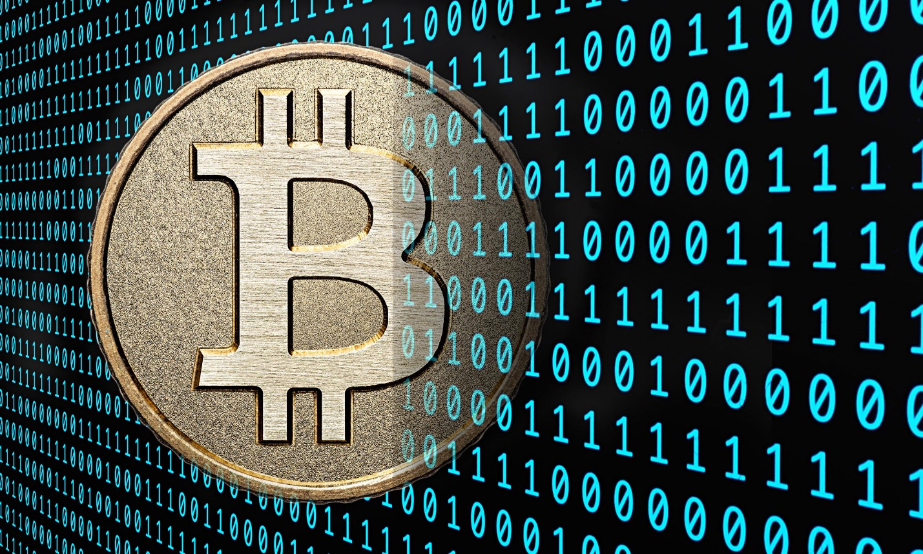
As if on cue, a seemingly perfect solution to everyone’s problems came onto the scene from nowhere. That solution was a mysterious and controversial digital currency known as Bitcoin.
Then, as if on cue, a seemingly perfect solution to everyone's problems came onto the scene from nowhere. That solution was a mysterious and controversial digital currency known as Bitcoin.
This unusual software protocol was designed for online asset transfer in 2008 and released in 2009 by the shadowy Satoshi Nakamoto. Nakamoto is a faceless figure who may not even exist, but he had supposedly invented Bitcoin and bequeathed it to the masses as a solution to many of the financial problems discussed above.
It was an unusual software protocol, designed for online asset transfer in 2008, then released in 2009 by a secretive 'Satoshi Nakamoto'. Nakamoto was and still is a faceless figure who may not even exist, but he had supposedly invented Bitcoin and then gave this gift to the world as a solution to many of the financial problems discussed above. Bitcoin emphasized fairness, innovation and freedom.
In the beginning the protocol existed as a pet-project for computer hobbyists and economic anarchists who gave away and traded Bitcoins amongst themselves for pennies. But one day a Bitcoin enthusiast managed to convince another to sell him two Papa Johns’ pizzas in return for 10,000 bitcoins. The coins were worth a few dollars at the time but are now valued now at over $1.5 million. That exchange was important because it proved the concept that people would swap something of value in return for Bitcoin. This is one of the fundamental prerequisites of a viable currency.
In the beginning the protocol only existed as a pet-project for computer hobbyists and economic anarchists who would give away and trade Bitcoins amongst themselves for pennies. But then one day a Bitcoin enthusiast managed to convince another Bitcoin enthusiast to sell him two Papa Johns' pizzas in return for 10,000 bitcoins. The coins were worth only a few dollars at the time but are now valued now at over $4,4 million. This exchange was important because it illustrated the concept to people of swapping goods in return for Bitcoin. This is one of the fundamental prerequisites of any viable currency.
From that point onward, Bitcoin began to rise from the bowels of the internet and gain exposure. It grew exponentially in both popularity and value and became world renowned as something truly new, a convenient and secure payment system for the future.
From that point onward, Bitcoin began to rise from the bowels of the internet and started gaining exposure. It grew exponentially in both popularity and value and became world renowned as something truly new, a convenient and secure payment system for the future.
The Bitcoin protocol itself is based on system-supported cryptography that crowdsources a global network of computers to verify transactions. This makes Bitcoin secure and fast enough to operate on a scale consistent with world currencies. It is easy to use, requires no third party trust (banks) and operates with extremely low transfer fees. All of these factors have led to public excitement about the platform and its rapid organic rise.
The Bitcoin protocol itself is based on system-supported cryptography that crowdsources from a global network of computers to verify transactions. This makes Bitcoin secure and fast enough to operate on a scale consistent with world currencies. It is easy to use, requires no third party trust (banks) and operates with extremely low transfer fees. All of these factors have led to public excitement about this platform and its rapid organic rise.
By 2013 Bitcoin-mania had reached fever pitch and each digital token was valued at a whopping $1216. It seemed that almost within the blink of an eye the focus of all discussions concerning the future of finance began to shift towards Bitcoin and those tools and services that could be built on top of it.
By 2013 Bitcoin-mania had reached fever pitch and each digital token was valued at a whopping $1,216. It seemed that almost within the blink of an eye the focus of all discussions concerning the future of finance began to shift towards Bitcoin and those tools and services that could be built on top of it.
As we began to enter the cryptocurrency age, news agencies contantly published Bitcoin stories, trading websites enjoyed huge growth, and there was a surge of interest from investors as public and private businesses alike clamoured to adopt the technology and accept payments.
As we began to enter the cryptocurrency age, news agencies constantly published Bitcoin stories, trading websites enjoyed huge growth, and there was a surge of interest from investors as public and private businesses alike clamored to adopt the technology and accept payments.
Today people can buy clothes, pay employees, make political donations and even fund space travel with Bitcoin. The currency is accepted by Microsoft, Target, Subway and Amazon and the list is growing daily. High profile names like the Winklevoss brothers and Andreessen Horowitz have pumped millions of dollars into the technology, and even public bodies want in on the act. The University of Nicosia in Cyprus is accepting Bitcoins for education fees and the Medicover group allows people to pay for treatment at hospitals in Poland.
Today people can buy clothes, pay employees, make political donations and even fund space travel with Bitcoin. The currency is accepted by Microsoft, Target, Subway and Amazon and the list is growing daily. High profile names like the Winklevoss brothers and Andreessen Horowitz have pumped millions of USdollars into the technology, and now even public bodies want in on the act. The University of Nicosia in Cyprus is accepting Bitcoins for education fees and the Medicover group allows people to pay for treatment at hospitals in Poland.
Unfortunately, not all opinions about Bitcoin have been positive or optimistic. Where there is a profit to be made and few regulations, there will also be unscrupulous practices. Add to this the inherent instability of a young market and it is easy to see why the Bitcoin name has become synonymous with negativity for some in the establishment.
Unfortunately, not all opinions about Bitcoin have been positive or optimistic. Where there is a profit to be made and with few regulations, there will be unscrupulous practices. Add to this the inherent instability of a young market and it is easy to see why Bitcoin’s name has become synonymous with negativity for some in the establishment.
It is true that Bitcoin crashes have occurred and caused much chaos in people’s personal and business lives. One such downturn even allegedly contributed to the much-publicized suicide of Singapore-based Bitcoin investor Autumn Radtke. There have also been arrests relating to Bitcoin-based narcotics sales, insider trading, and hacker attacks on exchanges have led to the loss of millions of dollars.
It is true that Bitcoin crashes have occurred in the past and these caused much chaos in people's personal and business lives. One such downturn even allegedly contributed to the much-publicized suicide of Singapore-based Bitcoin investor Autumn Radtke. There have also been arrests relating to Bitcoin-based narcotics sales, insider trading, and hacker attacks on exchanges have led to the loss of millions of dollars.
These kinds of events have often prompted negative reactions from national governments, attempted bans, and pessimistic views from the mainstream media. Which have, in turn, contributed to a market of peaks and troughs in which the first whiff of negative coverage sends the price crashing to floor before a resurgence occurs as waves of new investors rush in to eat up the cheap Bitcoin and propel it back ‘to the moon’.
These kinds of events have often prompted negative reactions from national governments, attempted bans, and pessimistic views from the mainstream media. Which have, in turn, contributed to a market of peaks and troughs in which the first whiff of negative coverage sends the price crashing to floor before a resurgence occurs as waves of new investors rush to buy cheap Bitcoins and propel it back 'to the moon'.
In such a system, free-market mechanisms take over and make it difficult for short-term investors to reliably assess the direction that the Bitcoin market will move. They are powerless before the Tsunami and can only watch and hope for the best.
In such a system, free-market mechanisms take over and make it difficult for short-term investors to reliably assess the direction that the bitcoin market will move. They are powerless before the Tsunami and can only watch and hope for the best.
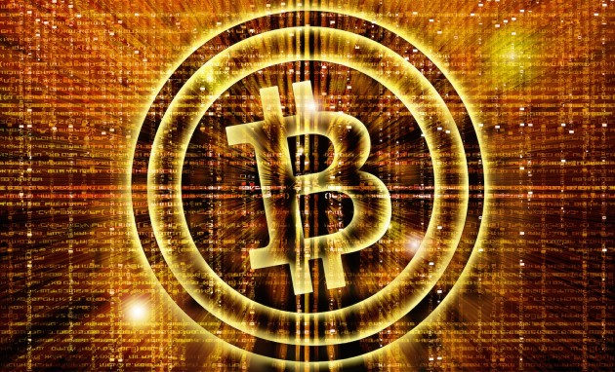
But despite all of this, the Bitcoin technology itself has weathered all storms that have come upon it and appears to be stabilizing. The general viewpoint is that as a method of value transfer the technology is sound, and the worst deviancies of a young market will pass once properly regulated.
But despite all of this, the Bitcoin technology itself has weathered all storms so far and now appears to be stabilizing. The general viewpoint is that as a method of value transfer the technology is sound, and the worst deviancies of a young market will pass once properly regulated.
Much of this regulation has begun to take place already and Bitcoin is entering a stage of maturity. With each day that passes it becomes a more secure and viable method of digital exchange for merchants and traders. Even governments are beginning to get on board with the dawning of the cryptocurrency era and it seems that this web-based decentralized cash has arrived at exactly the right time.
Much of this regulation has begun to take place already and Bitcoin is entering a stage of maturity. With each day that passes it becomes a more secure and viable method of digital exchange for merchants and traders. Even governments are beginning to get on board with the dawning of the cryptocurrency era and it seems that this web-based decentralized cash has arrived at exactly the right time.
With regards to Government regulation. Most governments allow the creation and circulation of alternative currencies within a community. However when any barter is done without the use of the standard national currency (such as US Dollar), taxation still applies on the fair market value of that transaction, just as if the normal national currency would have been used. As long as Governments are confident that taxes will be paid, they will stand in the way of financial regulation.
There is now little doubt that Bitcoin technology will form the basis of money in the future one way or another, and the industry is still wide open for new entrants. Make no mistake about it, those who embrace and learn to survive and thrive in this new world of digital currency will become the movers and shakers of the future. So, those businesses and individuals who wish to stay ahead of the pack should endeavor to learn as much about it as possible.
There is little doubt now that Bitcoin technology will form the basis of money in the future, one way or another, and the industry is still wide open for new entrants. Make no mistake about it, those who embrace and learn to survive and thrive in this new world of digital currencies will become the movers and shakers of the future. So, those businesses and individuals who wish to stay ahead of the pack should endeavor to learn as much about it as possible.
Just a handful of vendors who already sell goods and services are Microsoft, Dell, Overstock, Newegg, TigerDirect, Monoprix, Bitcoinshop.us, AirBaltic, Air Lituanica, CheapAir.com, BTCTrip, The UK’s Theatre Tickets Direct, WordPress, Amazon, Target, CVS, Subway, Victoria’s Secret, Namecheap, Virgin Galactic, The Pirate Bay, Reddit, Zynga, PayPal, Tesla, OkCupid, 4Chan.org, EZTV, Expedia.com, Zappos, Whole Foods, Jeffersons Store, TechCrunch.com, Fancy.com, Bing by Microsoft, Bloomberg.com, Humblebundle.com, BigFishGames.com, Suntimes.com, San Jose Earthquakes, Square, Home Depot, Kmart, Sears, Gap,GameStop and JC Penney, Etsy Vendors, Fight for the Future, i-Pmart (ipmart.com.my), curryupnow.com, Dish Network, Apple’s App Store, Newegg.com, ShopJoy, Wikipedia, Lv.net, ExpressVPN.com, MIT Coop Store, Shopify.com , Naughty America, Lionsgate Films, Badoo, RE/MAX London.
It is my sincere hope that this book will help you to gain the valuable insight you need to help you along through your upcoming Bitcoin journey.
It is my sincere hope that this book will help you to gain the valuable insight you need to help you along your upcoming Bitcoin journey.

Bitcoin

When we use the term “Bitcoin” we are referring to one of two things.
1. A unit(s) of digital currency
2. A computer software protocol (set of programmed rules) which is the framework needed for that digital currency to exist and function.
A Bitcoin is simply a digital record in an active and growing public ledger that keeps track of who owns what within the Bitcoin system. It is important to understand that there are no physical bit ‘coins’, only records of ownership of units of value.
This ledger is known as a ‘blockchain’ because transaction records are recorded in groups known as ‘blocks’ and the blocks are chained together. When a Bitcoin is sent from one person to another it does not actually move anywhere, there is only an alteration in the ledger’s ownership record for that ‘coin’.

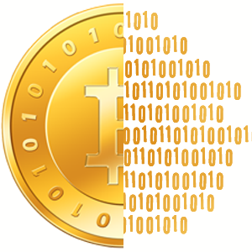
The ledger records ownership without revealing any true identities through the use of digital addresses (public keys), which function like pseudonyms. Ownership is ultimately determined by a secret digital key (private key) that affords the holder exclusive rights to transfer Bitcoins. When a transaction is made, this secret key is compared with its corresponding public key and if they match then the transaction is allowed (validated), if they do not match, then the transaction is refused (invalidated). This process is known as ‘digitally signing’ a transaction. More details information about how this works can be found in Sathoshi Nagamoto's Bitcoin White Paper section 2.
The owner is then able to spend Bitcoins on products and services from any business that chooses to accept them.

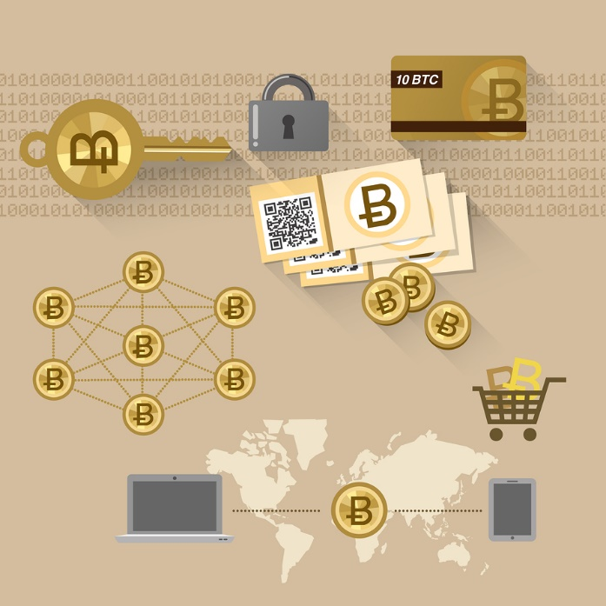

Operator of Bitcoin
There is no one company or organization that controls and operates Bitcoin. There is a Bitcoin Foundation, which is a democratic group tasked with being custodians of the network. However, they only exist to deal with public relations, and they have no official sanction to do so except from Bitcoin community members voting for them. They have no direct control over the software itself, its operation, or user’s funds.
Instead, Bitcoin is owned and operated collectively by all computers on the Bitcoin network. Any computer can become part of the Bitcoin network by simply installing the free open-source Bitcoin software package.
This decentralized approach was specifically designed for to deter malicious attackers and greedy central corporations. In order for Bitcoin to fail it would need all computers on the network to go down, which is unlikely to ever happen.
However, if a malicious entity was able to gain control of more than half of the computers on the network then it would be possible to reverse and block new transactions, and possibly even duplicate transactions to spend the same Bitcoins twice. This is the Bitcoin doomsday scenario, or what has become known as the mythical ‘51% double-spend attack’. But it is highly unlikely to occur, and if it did the whole world would know who did it, because any entity controlling 51% of computers would be easily identified.
So on the whole, Bitcoin is safe because it is owned by everyone and that is one of the major features that makes it special.

Creator of Bitcoin
Bitcoin started life in 2008 as a free, open-source computer program written by Satoshi Nakamoto. We do not know if Satoshi Nakamoto refers to one person or several, and the identity of that person or persons remains a mystery.
But this has not stopped many people speculating about who Nakamoto could have been. Some say he was a single brilliant libertarian benefactor trying to help humanity, others believe he was a government agent working for MI6 or the CIA. There have also been accusations that Nakamoto actually refers to a collective of individuals funded by powerful investors, or to a government program of some sort.
This has not stopped people speculating about who Nakamoto could have been. Some say he was a single brilliant libertarian benefactor trying to help humanity, others believe he was a government agent working for MI6 or the CIA. There have also been accusations that Nakamoto actually refers to a collective of individuals funded by powerful investors, or to a government program of some sort.
Whoever, he or they really were, Nakamoto’s involvement with the Bitcoin project in ended in mid-2010. At that point, the open-source community headed by Gavin Andresen took over responsibility for the source code.
Nakamoto has since disappeared and there has been no trace of him since that time. It is known he currently owns over $100 million in Bitcoins but the Blockchain shows that none have ever been spent.
The Nakamoto name is used in both the source code and within the study (whitepaper) that describes the Bitcoin concept. Nakamoto’s potential motivations for creating Bitcoin may be indicated by some of his mailing list discussions:
"It’s [Bitcoin] very attractive to the libertarian viewpoint if we can explain it properly. I’m better with code than with words, though." - Satoshi Nakamoto

While he may have been a libertarian, ironically, Nakamoto was not very good with code, he was only adequate with it. The Bitcoin code was very messy upon delivery and needed extensive editing by other programmers before it reached its current state. But the basic rules of the Bitcoin protocol were near perfect. Nakamoto’s genius was in the way he solved the fundamental problems of decentralized digital money, not in his practical coding skills.
This leads many people to believe that Nakamoto was actually a computer scientist and not a computer programmer by trade, because a computer scientist would be far better at understanding the relationships within computer-based ecosystems than actually writing code.
Seemingly as proof that he had created Bitcoin as an antidote to the 2008 financial crisis he hardcoded the following text into the first Bitcoin (genesis) block:
"The Times 03/Jan/2009 Chancellor on brink of second bailout for banks"
The Times is a UK newspaper and the chancellor in question is UK Chancellor of the Exchequer Alistair Darling. This leads many to believe that Nakamoto was an Englishman working from Great Britain and not Japanese as his name might suggest. This is also supported by his use of British-English expressions as opposed to American-English ones.
Recently an Australian by the name of Craig Wright came forward and claimed he was in fact Satoshi Nakamoto. Many major news organizations reported the story and he attempted to offer some tertiary proof. However, he never provided the ultimate proof of moving some of Satoshi’s coins on the Blockchain, and the Bitcoin community dismissed him as a scammer.
There have also been several people overs the years who have claimed to be Satoshi Nakamoto, but who have failed to proof such a claim. In 2016 an IT consultant who has long been involved with Bitcoin and suspected to be Satoshi, in fact claimed to be Satoshi Nagamoto. Craig Steven Wright from Australia has claimed to provide evidence of controlling block 9 of Bitcoin, which is known to belong to Satoshi Nakamoto, however after fully reviewing the evidence, it was found not to be sufficient. Therefor the matter is still open for debate.
So despite the clues we have, and the pretenders that have come forth, the true identity of the Satoshi Nakamoto remains open to speculation and will probably go down in history as one of the world’s most intriguing mysteries.

Why do Bitcoins Have Value?
Historically, most currencies have been backed by either commodities or exchange laws set by governments. Bitcoin is different in that it is theoretically not backed by anything other than a value that the free market gives it. Therefore, one might question whether it is worth owning at all.
There are however, some historical counterparts. Gold is the most obvious of these. The precious metal has always had value as a trading commodity despite the fact that it is virtually useless for anything other than decoration. But it is unclear whether gold without national sanction as a currency could even be considered a true currency.
However, there was one genuine case of a national currency that continued to perform well even after its medium of exchange standing had been revoked. That was the Iraqi Swiss dinar.
Following the First Gulf War, the Iraqi government replaced Swiss dinars with Hussein dinars. However, the original dinars continued to be traded in the Kurdish regions of Iraq as a result of issues concerning inflation of the new notes. That demonstrated that it is possible for a currency to survive even without any commodity to back it, so long as there are enough people willing to ascribe it value.
In the broader historical sense, all forms of money have always been deemed so because of the common understanding of what that money meant in the facilitation of fair trade. To be a store of value it has to map out and correspond to the real economy. Money has been mere entries onto bookkeeping systems for the last few hundred years within the banking system, because it was believed that the bookkeepers (bankers) where honest and facilitated fair trade.
So why do people give Bitcoins value?
- Utility: Bitcoins can be used to purchase goods and services wherever other currencies aren't accepted or convenient, most notably in dark markets, or developing nations.
- Exchange Value: Bitcoins can be exchanged for many different currencies on global exchanges. The term for this is ‘fungible’.
- Speculation: Bitcoin’s value is volatile and has surged in both directions. Speculators procure Bitcoins with the hopes of creating fast profits by playing the market. So Bitcoin has value as a speculative asset with a high volume of activity in the marketplace. The term for this is ‘liquidity’.
- Scarcity: The total number of Bitcoins is algorithmically restricted to twenty-one million Bitcoins, and they have not all been released (mined) yet. This maximum number of Bitcoins is hardcoded into the protocol and cannot be changed. When something is scarce and difficult to obtain it becomes valuable, and so has Bitcoin.
- Cost of Production: There is an additional reason that Bitcoin can be ascribed value, and that is the dollar cost per kilowatt of electricity needed to create (mine) new coins and secure the network. While this cost is significantly less than the face value of a Bitcoin, it is still a factor that must be taken into account.
- Fair: Its on open ledger (book) of all the records of transactions of a limited supply units. All the rules of the system are out in the open and all participants can only play by the rules. This means that all parties can in fact ‘trust’ the ‘bitcoin system’ as the ‘system’ is theoretically un-hackable.

Bitcoin as a Currency
Bitcoin is a digital, decentralized, peer to peer, pseudonymous currency supported by cryptography. If that sentence made no sense to you, don’t worry – here it is explained step by step:
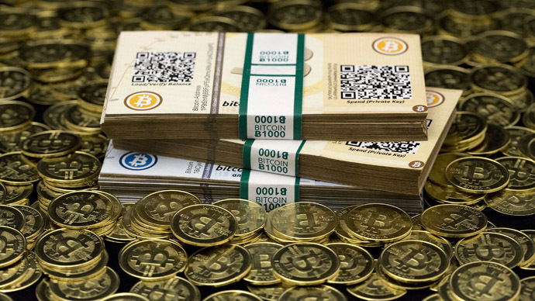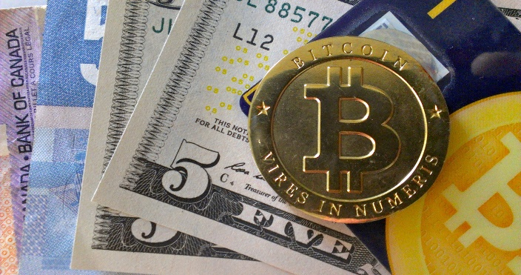
- Digital – Bitcoins exist solely within code and not as physical objects. People have created physical representations of Bitcoins but these are simply gimmicks used for aesthetic purposes. The so-called physical Bitcoins normally have a wallet address written on the back and this is where their true value lies, in the digital domain.
- Decentralized – There is no single financial organization or institution that controls Bitcoin. It is controlled collectively by all of the people around the globe who are running Bitcoin software.
- Peer to Peer – You manage your Bitcoins, and if you send a Bitcoin to another person, it goes directly to them. There are no banks, middlemen or higher authorities. All of the people on the network are peers, which means they have equal power and voting rights proportionate to their input.
- Pseudonymous – Pseudonymous is as close to anonymous as possible without being fully anonymous. If people are careful protecting their identity, they may use Bitcoins in a way that appears anonymous. However, all Bitcoin transactions are visible to the public on the open ledger known as the Blockchain, with the sender and receiver referred to by a string of numbers and letters. Anyone can track and trace these transactions, and while their names can never be discovered by examining the Bitcoin protocol, people will often leave other clues outside of it which leads to their identity being unmasked. So we use the term pseudonimity rather than anonymity.
More information can be found about the Privacy mechanisms implemented into Bitcoin from Sathoshi Nagamoto's Bitcoin White Paper section 11.
- Cryptography – Cryptography is the study of codes. The Bitcoin protocol uses virtually unbreakable cryptographic security to confirm that each Bitcoin transaction is valid and being sent by those with the correct permission. The cryptographic algorithm Bitcoin uses (SHA-256) was one developed by the US National Security Agency.

Bitcoin is the first digital currency to have all of these characteristics, and as a result, it has become the primary digital currency adopted on the net. It is currently handling over 200,000 transactions every day and this figure is constantly growing.

Bitcoin as a Payment System: Resolution of the Double-Spend Problem
As a brand new digital currency, Bitcoin is spectacular. However, the protocol itself makes for an impressive and revolutionary payment system alone. Before we consider the reasons why, let us first examine one of a few reasons why past attempts at decentralized digital currencies have failed:
In the physical world, cash cannot be in two places at once. Once you pay for something with it, it enters the recipient’s possession, and cannot be in yours or anyone else’s possession at the same moment in time.
With digital currency, this is not entirely true. Since digital currency is simply data, then it is possible to trick a digital system into thinking an equivalent unit of cash resides in multiple places at once. This issue is clearly a problem as it will lead either to mistakes or purposeful fraud.
In fact, the traditional banking system can occasionally be subject to this type of fraud, and it was even more widespread in the past. In the 1980s when debit card systems were less advanced, it was common for fraudsters to enter a store in one city, country or state and buy many items on a card. They would then pay for a flight, or train on the same debit card to another part of the world, and buy more items before moving on. They were able to do this because it would take a few days before systems could catch up and properly register that there was no money left on the card. Those fraudsters were double-spending.
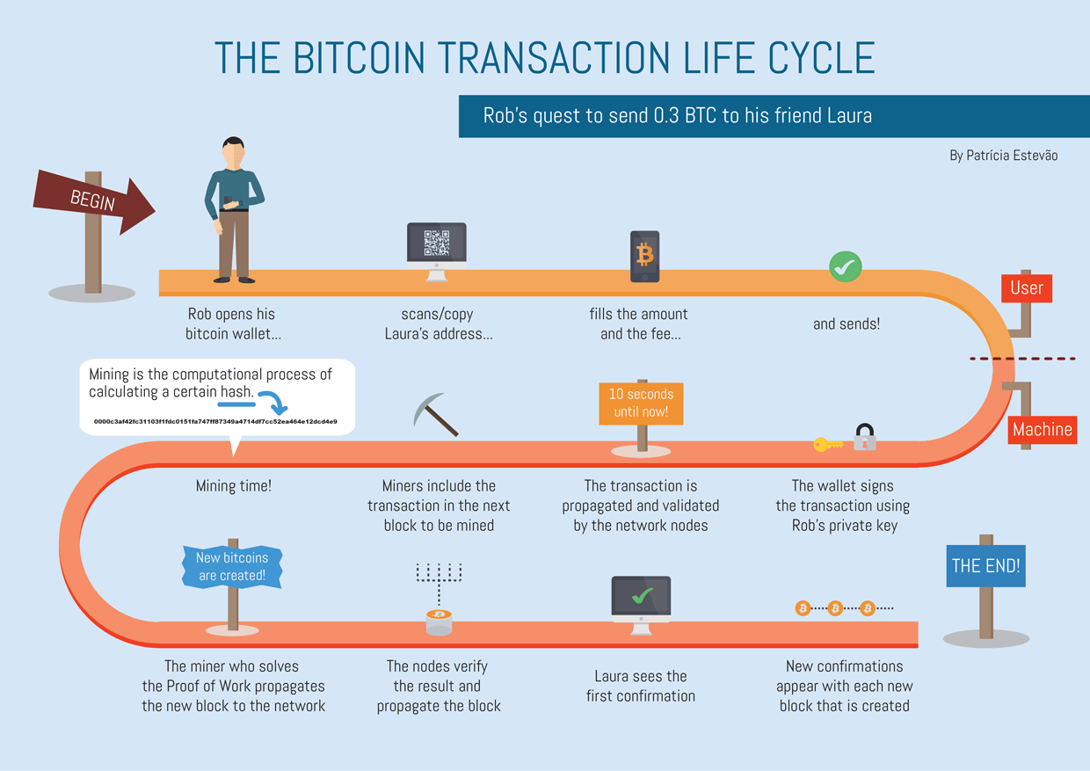
However, we tend to do many more digital transactions nowadays, so why do we not hear much about double-spending anymore? Well, systems like PayPal or VISA are much more advanced now than they ever were in the past. They have complicated security systems in place that review all transactions to confirm cash has not been spent twice.
Even still, some clever fraudsters occasionally get around this and manage to play the system. But the reason that the banking world does not come crashing down is centralization. Centralization allows financial service providers to take steps to protect themselves.
When individual fraudsters succeed in breaking the system, the centralized company just covers the loss with its insurance. Expensive and annoying yes, but these companies are making so much money that they can afford it, or more accurately speaking, you can afford it, because they pass on the cost of fraud to you in the form of increased fees.
However, the downside to centralization is that there is one central point of failure. It may be possible to cover the cost of one, or even many individual fraudsters stealing a few thousand dollars. But what if someone manages to hack into the system and steal everything? Then the company would collapse and be unable to pay everyone who held money in their accounts.
The same goes for a war scenario or some other huge catastrophe that could cause total systems failure. The firm would go to the wall and your money with it. It is unlikely, but always possible.
But there does not even need to be such a fantastic scenario. A company might just make bad moves on the stock market and go bankrupt, which is exactly what occurred in the 2008 financial crisis. Those failing banks just happened to be lucky that governments were willing to bail them out with your taxes, but will that always be the case? It seems unlikely.
There is also a risk that a centralized company may simply abuse the power it has over its users. For example, if a bank were to have technical issues, or for whatever reason consider you a persona non grata, they might just decide to freeze your account and not give you your money. This also happened during the financial crisis, when people in Cyprus were simply told they were not allowed to take their own money out of banks!
But Bitcoin alleviates the need for centralized companies and all of the problems that come along with them. Bitcoin has no central failure point and operates with very low fees, we will discuss exactly how it manages this feat later in the book.

The History of Bitcoin
We have discussed who created Bitcoin, but what happened next? Even though it is less than a decade old, it already has a distinct and interesting history.
Nakamoto had published his Bitcoin concept in October 2008 in an online document that became known as the Bitcoin white paper. This led to the tradition in the cryptocurrency industry for all new cryptocurrency releases to begin with the publication of a white paper.
Nakamoto then created the primary software package that enables mining (the method of making Bitcoin) and in January 2009 he mined his first batch of Bitcoins, named the Genesis Block.
Shortly after, he announced the project to a group of cryptography enthusiasts, several of whom considered themselves part of an underground cultural movement known as ‘cypherpunk’ (a play on the term cyberpunk). Nakamoto supposedly reached out to them because he had developed several of his Bitcoin concepts following the study of previous cypherpunk works. But it is worth noting that he never met them in person and all communication was carried out via the internet.
Initially, this cluster of laptop cryptographers approached Bitcoin as a stimulating hobby, discussing ways in which the system could work, and how governments might react to it.
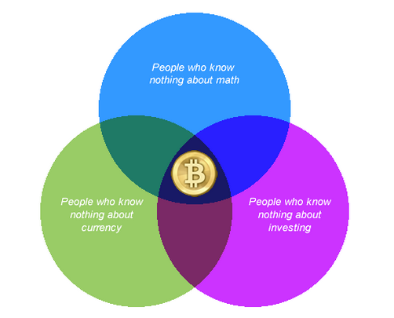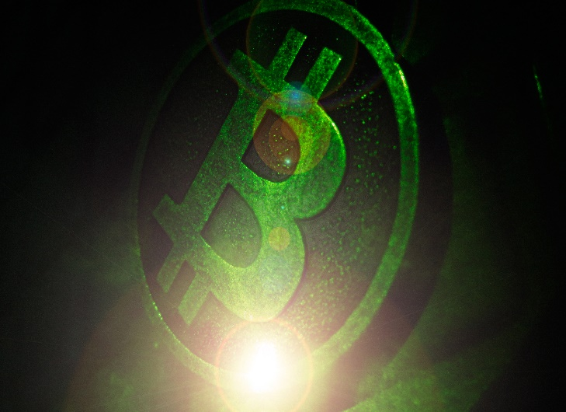

It was not until early 2010 that Bitcoin started being used for real-world transactions. By that time, Nakamoto and the wider community of developers had reviewed the code properly and free version (0.2) was available for mass download.
The first tangible Bitcoin deal for a physical object occurred in 2010, when a user named Laszlo purchased two pizzas worth $25 for 10,000 Bitcoins. This deal spawned the ‘Bitcoin Pizza Index’, a regular update on the dollar value of those Bitcoins used to buy the pizzas.
The Bitcoin community gradually expanded throughout 2010. At that time the infamous Mt. Gox (Magic: The Gathering Online Exchange) was the most important Bitcoin exchange, and in those days was synonymous with trust and good practices (in stark contrast to its final years).
Mt. Gox had been founded by Ripple programmer Jed McCaleb as a way for people to trade Magic: The Gathering cards. He presumably realized there was more money in trading Bitcoins than cards, and the company was converted into a Bitcoin exchange.
The advent of Mt. Gox and other exchanges made it easier for the public to buy and sell Bitcoin. So its dollar value began to climb, and it eventually reached parity with the US dollar in Feb 2011.
Bitcoin’s ascent may be largely attributed to increased media scrutiny over its use as a payment method for the Silk Road website.
Silk Road was a hidden website on the Dark Net which could only be accessed with the Tor browser. It allowed users to shop for and sell illegal merchandise such as drugs and weapons. The items were paid for with Bitcoin and then shipped by mail to customer’s houses. When news sites began reporting about this, many readers starting looking into Bitcoin, both out of interest in buying illegal items, and keenness to explore such a novel payment concept.
This new attention drove the value of each Bitcoin higher, until it reached a record $31 per unit in June 2011. By now, the early bitcoiners and cypherpunks were all multi-millionaires, including Nakamoto, if he ever decided to claim his coins.
However, in the same month, Bitcoin’s meteoric price rise suffered a correction when Mt. Gox’s security systems were compromised by hackers. The hackers caused the value of a Bitcoin to drop to 1 cent on the exchange as they stole hundreds of thousands of units. The hack caused many people to lose confidence in Bitcoin and the media wrote the currency off as a failure. However, the fault clearly lay with the Mt. Gox exchange and not with the Bitcoin protocol itself.
But the bad press was not enough to stop Bitcoin for long. It slowly began to attract additional users and followers throughout 2012, enticing several businesses to begin accepting it as payment for goods and services.
The real breakthrough year for Bitcoin was 2013. At the beginning of that year it was trading at around $13 per coin, and then began steadily rising as well-known net brands like WordPress and Reddit came on board. New users entered the market with them, supply could not meet demand, and prices rose sharply. By April, each Bitcoin was worth a staggering $266.
But there were further technical issues at Mt. Gox, this time involving a protracted lag for placing new orders on the exchange. Investors panicked when they saw charts freezing and prices tanking. So they flooded the market with sell orders and drove the price all the way down to $55 over only a few days.
To add further injury, it was also around this time that Bitcoin suffered its first major technical hitch in the form of an unplanned fork. A fork is when the Bitcoin Blockchain splits in half. Half of the network’s computers believe that the original ledger is valid, and the other half believe a second ledger is valid. Of course, only one ledger can be truly valid, so eventually the entire network decides which.
Forks can be purposely planned in order to introduce some change to the software, or they can happen by accident. The 2013 fork was accidental, developers had introduced a change into Bitcoin’s back-end component Bitcoind, which upset the software’s rules and caused the Blockchain to split.
No one had ever witnessed an accidental fork outside of a theoretical environment before. So the price dropped to half its value amidst doubts that the network would really be able to survive.
But luckily, Bitcoin proved to be as robust in reality as it was on paper, and after six hours of bated breath the fork resolved itself. All of the computers finally agreed on one Blockchain and caused it to pull ahead, leaving the other one behind. This proved to the world the technical capability of Nakamoto’s invention.
But Bitcoin’s bad luck in 2013 was not over yet. In October, US law enforcement officers closed down the Silk Road website and made several arrests. Since at that time Silk Road accounted for most Bitcoin merchant sales, many expected the currency to become next to worthless. However, the exact opposite happened.
The FBI had seized millions of Bitcoins from Silk Road and were now declaring them to be the proceeds of crime. This amounted to de facto acknowledgement from the US government that Bitcoin was a real currency. Chinese investors started clamoring to buy coins, while the masses of publicity generated by the bust encouraged lots of people to purchase Bitcoins on eBay and other mainstream websites.
These factors resulted in the biggest bubble ever in November 2013 as the Bitcoin price rose from $300 to reach its highest price ever, a jaw-dropping $1216.72. The price crashed, rebounded and crashed a few times more, before finally settling at around $800 per coin as 2014 dawned.
But there was more trouble to come. Amidst ongoing legal problems, Mt. Gox froze all Bitcoin withdrawals from its website and ceased trading. The company issued various statements, which were met with skepticism and consternation from the Bitcoin community. Then the price started crashing as traders panicked that everyone might lose their coins. Total freefall ensued when the company announced that they had lost a great many coins due to a ‘transaction malleability’ bug in the Bitcoin protocol.
There is still some doubt among many as to whether or not ‘transaction malleability’ ever really existed in the way it was described, or if it was part of a cover up by Mt. Gox. In any case, the bug was supposedly fixed but Mt. Gox closed down completely and its CEO arrested for fraud.
So, Bitcoin had lost its two biggest marketplaces; Silk Road and Mt. Gox and its price has never fully recovered from this period in its history. However, once free of the shady and illegal aspects surrounding it, the ecosystem started to mature. Bitcoin hearings were held in New York between major Bitcoin players and regulators to discuss the future of the technology. The US government introduced legislation to make trading more secure and stamp out illegal behavior.
Serious investors and firms saw this positively and Bitcoin began to be seen less as strange electronic drug money and more as a viable payment platform for the future. Major companies and household names began putting their weight behind the platform and even Microsoft started catering to bitcoiners.
As of 2016, the Bitcoin price has begun steadily climbing again, but this time the rise is slow and steady, a state of affairs that is desirable for a stable, long-term ecosystem, and is preferable to the boom and bust economics of the past.
At the time of writing, the entire number of Bitcoin transactions has topped one hundred million, and the market cap (number of Bitcoins x the price) is over $7 billion. It is not known precisely what percentage of people use Bitcoin, however, estimates are generally between 200k and 400k, and growing steadily.
In absolute numbers, the U.S. has the most Bitcoin users, however per capita, Scandinavian countries come out on top. The fastest growing adoption rates are currently amongst the Chinese, and the developing nations are the slowest, possibly owing to their lack of technological infrastructure. But with the increasing availability of mobile, all that can change.
Whatever happens, it now seems unlikely that the Bitcoin market will ever return to the kind of instability we saw in its teenage years.

Why Use Bitcoin?
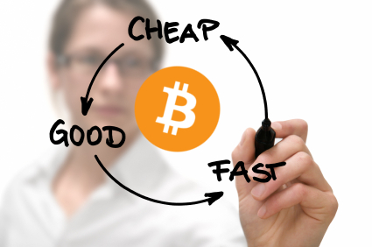

The Advantages and Disadvantages of Digital cash
Now that you have gotten a general sense of Bitcoin and its history. You might be wondering why you should use it at all, and what's wrong with our current money?
It is true that Bitcoin isn’t for everybody. It requires some technical know-how to obtain, use and safely store. Its marketplace is volatile, with rapid value fluctuations that can cause mayhem for investors. Despite the fact that these issues may be resolved in time, they nevertheless represent an entry barrier for many.
But there are many drawbacks to our current financial system too, and they make Bitcoin appealing. Most of these might be gathered under the heading: Trust.
Reducing the trust required to make transactions was one of the primary motivations behind Bitcoin in the first place. As Nakamoto’s original paper states:
“We have proposed a system for electronic transactions without relying on trust”
To use cash in a traditional economic system, you need to place a lot of trust in multiple establishments:
- Banks. When you deposit something in a bank, you're trusting that they will not go bankrupt and are going to be able to pay you back when you come to withdraw again. But as we have seen over and again in history; bank runs and monetary panics prove that you can never be certain of that.

- Central Banks. The U.S. has the Federal Reserve System, the European Union has the European Central Bank, Japan has the Bank of Japan, and it is much the same the world over. Countries all have central banks that manage their currency supplies. Typically, the currencies these banks issue are not backed by any goods, and only have an assigned phantom value. They are known as fiat currencies. We simply have to trust that central banks will not produce an excessive amount of fiat currency, which would cause hyper-inflation and make it almost worthless. Sadly, since the financial crisis of 2008, central banks across the globe have employed quantitative easing programs which do involve printing additional fiat currency. It can be argued that such programs will undoubtedly lead to an excess of inflation at some point further down the line.

- Payment Processors. We have a tendency to trust that after we pay for something online, our payment processors will not reverse the transaction, and that they will guarantee there are no double-spends. Likewise, we trust that they are going to permit us to allow whomever we like to pay us for our services. But this is not the reality. When controversial whistleblowing organization WikiLeaks attempted to solicit donations in 2012, Visa and PayPal refused to permit donations from their supporters.

- Governments. Events in Cyprus throughout March of 2013 show that fiat currencies are a liability when governments have control over them. People who held investments in the country’s banks at that time had some of their assets seized to go towards repaying its national debts. Governments also have a habit of limiting the kinds of things you can spend your money on. For example they prohibit you buying things like medicines, foods, sexual services and gambling. You may agree that some of these should be restricted, but you must also agree that a government telling you what you can or cannot spend your money on at least suggests a reduction in personal freedoms.

- Identity Required. You need to submit your identity to banks, payment processors, and governments if you want to actively use the modern marketplace. This is justified by various anti-money laundering laws and so forth. But perhaps you wish to remain anonymous for your own reasons. And in any case, you may not be able to trust these organizations with your information, especially since many now outsource their jobs all over the world.

How will Bitcoin reduce the need for these institutions? Let’s address them one by one:
- Banks. Few banks would be needed in a Bitcoin-based economy. Instead, you would manage your own currency in a Bitcoin wallet. Assuming you took the correct precautions, you’d be able to take out and use your Bitcoins just as you pleased.

- Central Banks. Bitcoin was not created by and is not managed by any central establishment. Its network creates new Bitcoins at an algorithmic rate that cannot be influenced by greedy human beings. Therefore, there is no need to worry about manufactured inflation.

- Payments Processors. There will be no payments processors needed in a Bitcoin-based economy. This is because Bitcoin is peer-to-peer, so all transactions can take place between users on equal terms, and no middlemen are required.

- Governments. There is little that governments can do to negatively influence the Bitcoin protocol. They cannot interfere electronically with transactions, or change Bitcoin’s rules and methodologies, and they cannot confiscate coins in wallets that they don’t know the password for either. However, they aren’t utterly powerless; they can still target exchanges, individuals or companies using Bitcoin and put pressure upon them. Yet, their overall control over Bitcoin compared with their own fiat currencies is minimal.

- Identity Not Required. You can be virtually anonymous when using Bitcoin. No government or banking agency is going to force you to submit your passport and home address before you can use your Bitcoin wallet.

So if we used Bitcoin instead of fiat currencies we would no longer have to place trust in the institutions listed above. We would instead trust in ourselves and the Bitcoin network. Most of us know we can trust ourselves, and we can trust the Bitcoin network too, since it is merely a set of computer rules with no emotions like greed, or a thirst for power to encourage it to make selfish decisions.
The negation of trust was arguably the most important factor for Nakamoto when he came to create the currency, but there are several additional positives that Bitcoin offers:
Straightforward Usage: Once you get the hang of things, Bitcoin is actually very easy to use. All you need do, is input the receiver’s public address (often done by simply scanning a QR code), enter the quantity of currency to send, and hit the send button.
Net Integrated: Bitcoin was custom-built for the web from the ground up, and it shows. Integrating the protocol with online services is very simply done. Several websites even provide pre-built Application Programming Interfaces (API) for Bitcoin services in order to streamline transaction integration and make reading the Blockchain a breeze. A good example of Bitcoin web integration is Changetip, which began on the well-known content aggregator Reddit. It permits users to send Bitcoin to content creators across a huge spectrum of social media sites, including Reddit itself.
Quick: A Bitcoin transaction happens as quickly as sending an email, which is much faster than traditional wire transfers which can take days. However, such performance does require you to keep your Bitcoin wallet updated with network data, a point which we will consider in detail later in this book.
Secure: The cryptography that secures Bitcoin is incredibly advanced, and it is currently impossible for anyone to interrupt or break into the network. All thefts of Bitcoins have occurred due to improper storage by users, or from people hacking into exchanges and other services. Cyber-security specialists the world over are constantly testing the network in an attempt to find security holes and backdoors into the code, but so far nobody has ever managed to break it.
Deflationary: Since there can only ever be twenty-one million Bitcoins created, and since the rate of new coins slows as more resources come into the network, then the scarcity, and therefore potential value of each coin should constantly increase. This makes the currency inherently deflationary, and the opposite of the traditional inflationary currencies.
Due primarily to these advantages, Bitcoin use has grown exponentially since its introduction in 2009, and shows no sign of stopping.
However, even Bitcoin is not perfect, so here are its disadvantages:
Steep Learning Curve: Many people can be turned off from Bitcoin before they have even tried it. Due to their perception of its complexity, they might feel bored and intimidated at even the thought of learning all about cryptography, blockchains, mining, wallets and code just to make a payment. However, it is really not necessary to become an expert in all of these things if you wish to simply use Bitcoin, you just need to understand is how to use a wallet. Additionally, as the currency becomes more fashionable, there are more efforts being made to produce works like this book you are now reading, which help make Bitcoin accessible for you.
Getting Bitcoin: Laying your hands on some coins can be somewhat difficult for a beginner. It might take days or weeks of research before they can find a reliable place to buy them and work out how. But this is another area that is changing for the better. New people who are willing to sell Bitcoins person to person constantly enter the scene, while new exchanges rise to fill any gaps.
Confirmation Takes Time: Transactions on the Bitcoin network do occur quickly. However, the checks that ascertain that the remainder of the network agrees that those transactions are valid take time. These checks are called confirmation, which for larger transactions can take an hour or more. Obviously, you do not have to sit and wait for confirmation to happen, but it can nevertheless become a negative factor when you need to perform many transactions quickly, for example in a trading environment.
Personal Wallet Security: Just like a real wallet or store of money, if you do not protect your Bitcoin wallet, you can easily have your money stolen. Securing your Bitcoin wallet password can be tough, since any PC connected to the web is vulnerable to being snooped on or hacked. There are of course common-sense ways to secure passwords, but most require vigilance and some technical know-how.
Restricted Acceptance: While the number of merchants accepting Bitcoins is increasing daily, they still represent only a tiny fraction of the global economy. For online services in particular, Bitcoin is gaining fame and credibility. However, in some traditional sectors, it has barely made any inroads, and it will still take many years for Bitcoin to ever be accepted by the general population in the same way as Visa and PayPal.
Unsure Future: Although all signs point towards Bitcoin becoming the web’s foremost currency, there are certainly no guarantees. There is still a chance that it could crash and burn, leaving many users with worthless coins.
So, after considering all of the advantages and disadvantages of Bitcoin, should we conclude that is worth using overall? Well, it seems that the rest of the world is beginning to think just that.
In the network’s early history, the typical Bitcoin user was a technically adept young man in his late 20’s or early 30’s with libertarian political leanings. He was attracted to Bitcoin for obvious reasons; it was technologically based, new and exciting, and fed his political ideals about a society with less governmental interference.
But this profile of the conventional Bitcoin user has almost completely broken down since 2013, when users from different demographics began entering the scene. The new breed of Bitcoin users are often more concerned with its potential use in business strategies, and they have helped change Bitcoin into a system that is taken more seriously and viewed more positively by corporate elites.
PayPal business executive John Donahoe created headlines when he told the Wall Street Journal:
“It’s a new disruptive technology, so, yeah, we’re looking at Bitcoin closely…There may be ways to enable it inside PayPal.”
And it is more than just talk, many investors are willing to put their money where their mouths are. Peter Thiel’s Founders Fund has ploughed at least $2 million into the Bitcoin payments processor Bit-Pay, while Fred Wilson of Union Square Ventures has poured $5 million into rival company Coinbase. Cameron and Tyler Winklevoss of Facebook fame have bought up masses of the currency itself, and reportedly now own a significant percentage of all available Bitcoins.
These investors are not curious about Bitcoin as a result of a coding obsession, or a desire to bring about some kind of crypto-anarchist political state. They are interested because they believe that it will become the currency of the web in the near future, and think they can make money by getting into the game now.
But what about you, the average user, what should you do in the meantime?
Well, if you are a businessperson who primarily conducts your business offline, then an investment is probably not in your direct business interests at the moment. It would perhaps be more advisable to wait some years until Bitcoin’s infrastructure has grown and its economy has matured. By then there will be a smaller learning-curve, fewer barriers to getting coins, and you won’t be put off by the technology.
However, if you buy or sell products or services online, then it is well worth familiarizing yourself with Bitcoin right now. Vendors should realize that a vibrant Bitcoin community already exists and is growing, with members that are beginning to expect Bitcoin payment options to be available when they visit stores. If your business does not provide them, then they may assign you a lower market-value than they assign to businesses that do. Simply put; net businesses that do not start accepting Bitcoin now, may soon be left behind.
Buyers should understand that transactions are straightforward, quick, cheap, and do not require the submission of personal data. Simply trying Bitcoin will quickly allow you to perceive why so many people believe in it, and you have little to lose.
Yet there is another purpose for owning Bitcoins outside of the general arena of the internet economy, and that is investment.
There are two primary reasons people invest in Bitcoins:
- They believe that Bitcoin could shield their savings against the inflation that will result if central banks across the globe continue to devalue their currencies. So, they invest in Bitcoins and hold them as a hedge against national currencies. Although there is a valid concern over inflation, it is worth exercising caution before you follow them down this route. Bitcoin remains a young unproven currency, its market is volatile and we do not know for certain that the world will ever universally adopt it, even within a declining fiat currency environment.

- They believe that if Bitcoin becomes widely adopted and displaces national currencies it will become incredibly valuable. This belief comes from the fact that the number of Bitcoins that can be created is fixed. Some predict future Bitcoin values within the thousands, or even tens of thousands of dollars. But caution should always be taken upon hearing these kinds of predictions, because nobody truly knows the future value of a Bitcoin with certainty. However, the chance to make money is attractive, so people will always be willing speculate. And indeed, plenty of fun can be had playing the Bitcoin markets, and some profits can be made, so long as people only play with what they can afford to lose.

How does Bitcoin Work?
By now, you might be feeling a strong desire to go out and acquire some Bitcoins for yourself, and we will discuss how to do so in a little while.
But before that, it might be beneficial for you to grasp the currency’s inner workings. While it is by no means a necessity to fully understand Bitcoin in order to use it, it is at least worthwhile as a new user for you to familiarize yourself with the basics. In that way you will not be working entirely in the dark when it comes to your cash.

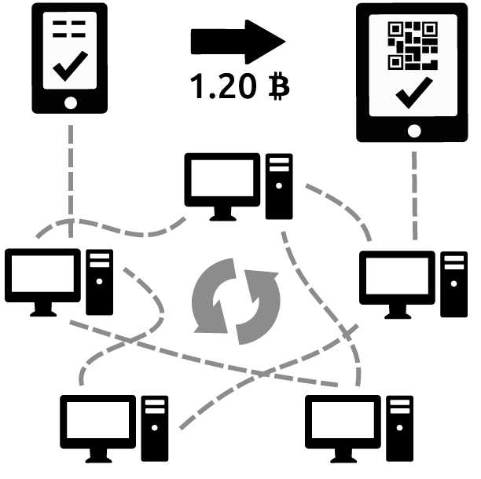

Cryptography
A peer-to-peer digital payment system like Bitcoin needs robust security against fraud. This next chapters will introduce the cryptographic technologies that were built into Bitcoin to guard against hacking and double-spending.

Cryptographic Hashing Algorithms
When information that needs to be secured is transmitted across a network, it needs to be incorruptible. A cryptographic hashing algorithm addresses this need. It takes a sequence of inputted data and computes a fixed-length alpha-numerical code (string) based upon it. We refer to this output code as a hash, and it has some special properties:
- It is easy to modify algorithms to make a hash from any digital input.
- Changing any part of the input produces a completely different output.
- Hashes are unique. Each output will only match a specific input and no two outputs are ever the same.
The hashing algorithm used by Bitcoin is called Secure Hashing Algorithm-256 (SHA-256). The output of SHA-256 is composed of 256 bits, or 32 bytes of information. Here are some examples of it in action (The sequences beginning with 0x are the strings resulting from the text inputs):
Sha256 (Bitcoin) =
0xb4056df6691f8dc72e56302ddad345d
65fead3ead9299609a826e2344eb63aa4
sha256 (Bitcoin) =
0x6b88c087247aa2f07ee1c5956b8e1a9
f4c7f892a70e324f1bb3d161e05ca107b
If you look closely you will see that the only difference between the two inputs is a minor change to the first letter but the output strings are vastly different.
Hash functions are not only useful for guarding against transmission failures, they also secure the input file against any potential changes by unauthorized people.
As an example, let’s say Alice and Bob measure two bedrooms that they are going to choose between, but one room is greater than the other. They each want the largest space, but it isn’t clear how much extra they should have to pay in order to get it. Neither one wants to be the first bidder because it will weaken their position. So they decide to use the following protocol:
1. Each writes down a secret bid for how much extra they'd pay for the bedroom each month.
2. Each places the bid face down on the table without showing the other person.
3. They only flip the papers over to reveal the bids after both are on the table.
4. They agree to award the highest bidder the larger bedroom, and use the average of both bids to determine the extra amount that the winner must pay.
Using this protocol, each party is sure to get a deal that is equal to or more attractive than the amount that they bid.
Now let’s say that Bob is out somewhere, so this method has to be performed remotely. If the pair try to use their protocol via phone or email, there will be no guarantee that they can announce their bids simultaneously.
But hash functions can solve this problem:
Alice and Bob could each write a sentence on a word processor like "I’ll pay $650", or "$700 is my bid,", then feed it into a hashing algorithm, and email the output hash to the other person.
Each would be in possession of the other’s bid, but would be as yet unaware of its actual contents. However, they would know the hash resulting from it. So if one amongst them tried to pretend their bid was something different, they could not succeed because their new false bid would not create or match the same hash.
So upon following this new idea and exchanging hashes, Alice and Bob perform a rehash and end up with each other’s bids. They know that the bids are correct, because only the output hashes can ever match what was input in the first place, and the SHA-256 algorithm cannot be mistaken or cracked.
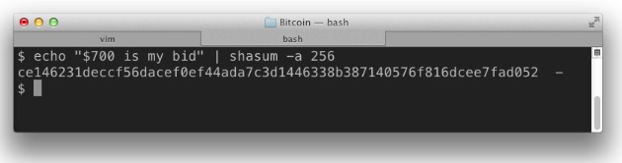
So, the point is, that we can hash any chunk of data we like to ensure that the info contained within it can never be tampered with. This is because once we know the hash, we also know the resultant output must always be identical to what was put in.
Creating an SHA-256 hash from a sentence can be done easily with free software like Chasm for Mac OSX, or Sha256sum for Linux.
Hashing can have many security uses in the real world. Imagine you have a passcode for a safe in which you store your gold. You could make a hash from the passcode for extra security, so someone would need to know how to decrypt the hash and get the code before breaking in. You might want to hide some valuable song lyrics, or notes about an invention, and you could hash those too to prevent prying eyes from stealing them. And of course, you could input actual software code into the hashing algorithm and secure that too.

Merkle Trees
Cryptographic hash functions are often used to verify the integrity of separate parts that make up a whole. An example of this is when a large file, like a movie, is broken up into many parts during a bittorrent transfer.
One way of doing this is to take a hash of the entire file with all of the chunks still merged together.
The problem with that, is that the user will not know that the hash matches up correctly until the entire file transfer is complete. So if a chunk of (for example) a virus is downloaded, the recipient will not know about it until it is too late.
Perhaps a better way would be to split the file into chunks first and then take a separate hash from each individual chunk. That way the user could verify each chunk separately as it arrived.
However, if there are a great many chunks from different sources arriving quickly, like in a bittorrent, then there is the possibility that some of the hash values can become corrupted by untrustworthy sources.
In such a case, the original trusted supplier of the file would need to provide a master hash made from all of the already hashed chunks cobbled together, which could then be used to verify the completed file at the other end. Once we knew the master hash we could trust files shared by third-parties, like the peers in your bittorrent software.
Within these types of systems, the master hash is known as the ‘top hash’, and all of the hashes together are known as the ‘hash list’.
So, in order to verify a chunk against the trusted top hash, one would need to get all of the hashes from the hash list. But if the number of chunks was incredibly large, then the hash list may also be huge, making it difficult to download them all before checking.
Computer scientist Ralph Merkle thought of a solution to this problem in 1979 with his invention of a hash tree. The hash tree allows each individual chunk’s hash to be compared against the top hash, without the need to download the whole collection of chunks.
To make a hash tree or Merkle tree, hashes are taken from all chunks in a file. These hashed chunks are subsequently paired, and then a hash of every pair is taken. This process is repeated over and again until there's just one hash at the top of this hash tree. The final hash becomes a special top hash that can be used to check any individual ‘leaf’ of the Merkle tree.
Peer-to-peer programs can make use of Merkle trees to reject corrupted data chunks. They download chunks one at a time and check the hashes individually. If the program finds a chunk with a hash that does not match the top hash, then it assumes it is damaged or fake, drops it, and searches for another chunk that is genuine.

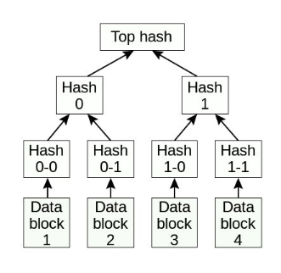
For example, if you needed to verify some information from Data Block 1 in the diagram above, you could use Hash 0-0, Hash 0-1, Hash 0, Hash 1 and then finally the top hash. But you would not need all the pieces of Hash 1, thereby removing Hash 1-0 and Hash 1-1 from the equation. For giant trees, the amount of hashes required to verify one chunk would still be numerous, but far less so than with traditional hash lists, which require every single chunk to be downloaded.

Public-key Cryptography
To understand Bitcoin itself, you need to understand the basic principles of public-key cryptography. This sounds complicated, but mainly implies that every user who needs to speak with another must have two passwords (keys). One key is public; so everybody can see it, while the other is private and known by the user alone.
Here is a basic example of public-key cryptography in action:
To send a secret letter, Alice would hash its contents to Betty’s public key. Alice would then send her letter and Betty would decrypt it using her non-public key.
The reason public-key cryptography is so powerful is that it does not matter if another person – let’s say Charlie – intercepts the letter. Even if he knows Betty’s public key he cannot decipher the letter without her private key.
So this technology allows anyone to send a letter (or any other information) out into the public domain (like onto the internet for example), but only the intended recipient would ever be able to read it.

Digital Currencies

Properties
A secure digital payments system ought to have the following properties to eliminate fraud:
- Legitimacy - Only the genuine owner of an amount of currency can send it.
- Security – The currency cannot be forged, and the owner can only spend the same currency once (resolution of the ‘double-spend’ problem)
- Nonrepudiation - Recipients cannot deny receiving currency they have in fact received.
Nonrepudiation is not as crucial assuming property 2 is present, because the sender would be able to prove that they sent the currency. However, if the system does not have property 2, then it might be not be possible to resolve a dispute in which a vendor denies receiving payment and refuses to produce merchandise in return.
There are three further properties that give this system a lot of power:
- Anonymity – A sender’s identity is never disclosed to a recipient or a third party (this often consists of three components: money handler anonymity, untraceability, and unlinkability)
- Offline – Users can send and receive funds without involving a third-party like a bank.
- Localized – There is no third-party like a bank required to mediate between transactions.
Digital cash is often defined as any digital payments system that satisfies properties 1-4. Bitcoin does not fully satisfy property 4, so some would say that it is not technically digital money. But it does semi-satisfy anonymity, and instead provides pseudonimity.

Double-Spending
All electronic payments systems rely heavily on cryptography, and digital signing can be used to satisfy most of the requirements of properties 1-3. However, digital signing does not actually solve the double-spending problem.
As we have already discussed, double-spending is a style of digital payments fraud in which someone uses the same cash twice.
Here is an example:
Imagine that Chuck owns a checking account with $100 in. And let’s say he opens two tabs in his web browser, one for Amazon and another for EBay. Using each tab he adds a $100 item to each of his carts, enters his checking account details, and completes checkout on both tabs at exactly the same time.
If Chuck’s bank was using a poorly implemented payments system, then each company would see that he had $100 in his account, approve the purchase, and allow him to walk away with $200 worth of products for only $100. So Chuck would have double-spent his $100.
For centralized online networks like those used by credit cards, the police could find out if double-spending had taken place quite easily. This is because information about all transactions and who made them is held in a central database.
But in offline or localized systems it is more difficult to find out, because they allow users in who have not been subject to the same kinds of background checks, and nobody controls the main ledger.
Solving this double-spending problem was a massive hurdle that decentralized digital payment systems needed to overcome. The trouble with discerning double-spending is that every payment would be fully legitimate if its double did not exist. So the only way to solve double-spending traditionally was to know all transactions and monitor them for duplicates.
When trying to deal with double-spend fraud cases, authorities are left with only a few different ways to proceed.
One choice is to try and find out the identity of the double-spender, the moment the offence is committed. But this would require all transactions to first be considered invalid and cleared one by one, severely slowing down the system.
The other is to assume that all payments are valid and sort everything out later. But this can be dangerous and insecure. So there has to be another system that can sort out double-spent payments right away.
We will consider Bitcoin’s answer to this problem later.

Types of Digital Payments Systems

Type 1. Credit/Debit Cards (Properties 1-3)
Most of the planet continues to use the most primitive forms of electronic payments systems: credit and debit cards. People using these to transact will never be anonymous, because business owners can see the cardholder’s name, and credit card companies can track their purchases. Transactions made with cards are considered ‘online’, since they require merchants to connect with a bank, or card company, in order to verify their validity. They are also considered ‘centralized’, since such systems cannot work without a central authority like the card company or bank. It follows then, that if the card company or bank in question decides to freeze a user’s account, they can do so and deny a user access to their cash at any time.

Type 2. Digital money (Properties 1-4)
In 1982, cryptographer David Chaum printed a paper called Blind Signatures for Untraceable Payments, which contained the world’s first description of a viable digital currency.
In Chaum’s projected system, banks would issue cryptographically signed digital notes that might be used anonymously like hard cash. People could request these digital notes from banks in exchange for an equivilent quantity of cash, and to fill a request, the bank would create a number of digital notes with their own secret cryptographic key.
Upon issuance, each note would have its value set to an agreed amount, let’s say $1, and the bank would deduct the corresponding amount from the customer’s checking account.
The bank would be aware of people they had issued the notes to, but would not be able to trace the notes or find out what they had been spent on.
Additionally, they would not be restricted to the original person; whomever had access to the notes could cash them, so they could be used in a similar manner to regular cash. But the bank would always be able to verify that the notes had indeed been issued by them and were therefore genuine, whenever someone tried to redeem them.
This is the magic of blind signatures that Chaum introduced, and he explains it via a simple paper-based analogy:
Let’s say Alice has an account at Chaum Bank and desires some blind signature notes (in Chaum’s analogy they are paper notes, not digital ones). She goes to the bank and approaches the table to look for some old fashioned credit note request forms.
However, at Chaum Bank, there are only stacks of blind note forms, envelopes, and carbon paper. Each blind note form features a long sequence of empty boxes that Alice is told to fill-in with random numbers to create a long serial number. Each envelope features a space for a signature that Alice is told to leave blank.
Alice fills in the serial number, then puts the blind note form, along with a carbon slip, inside an envelope. She seals it and brings it to the teller.
The teller asks for Alice’s ID, and signs the envelope with a special signature that sets its value at $100. She then deducts $100 from Alice’s account.
As Alice leaves the bank, she opens the envelope and extracts the blind note that now has Chaum Bank’s signature on the signature line due to the carbon slip’s presence in the envelope.
Alice goes to spend her blind note at her favorite store, and the next day the storekeeper takes it back to the bank to swap for hard cash. When the teller receives the blind note back, she examines the signature and verifies it to make certain that the blind note is genuine. If everything checks out, the bank credits the merchant’s account with $100.
In the cryptographic sense, Alice has produced a duplicate of the note, but only for purposes of anonymity. She could not modify its value or the bank’s signature in any way.
Alice knew the note belonged to her because she wrote the serial number on it before the bank signed it. But the bank did not know this number because the teller never saw it. Therefore Alice could spend her blind bank note wherever she wanted without anyone knowing her identity, even the bank.
Of course, in the real world, the storekeeper would still have to confirm that the note was genuine by communicating with the bank before giving Alice her merchandise. So we are still taking about an ‘online’ system, but it is a much faster method than searching through reams of transactions for a bad one.

Type 3. Offline Digital Money (Properties 1-5)
‘Offline’ payments systems present a big challenge that ‘online’ payments systems do not. Thuis is because there needs to be a way to verify and permit transactions without contacting a trustworthy authority, like a bank.
Initially, this might seem possible, because if a client uses an equivalent instance of digital money at two merchants simultaneously, and both merchants are disconnected from the remainder of the system, then there is nothing telling them that the money has been double-spent.
However, if the merchants ever manage to determine who the client is, then they might later sue them for fraud after they conclude that the funds were double-spent.
The downside to this resolution is that if a business owner needs to identify every client, then the system can have no anonymity. However, Chaum, Fiat, and Naor, in their 1989 paper Untraceable Electronic Cash, suggested a way to reveal a customer’s identity only when a double-spend takes place.
Their idea was to connect a pair of numbers to each digital money note, which in isolation would mean nothing, but in combination would provide the owner’s identity.
Whenever one of these notes is spent, the merchant would present a validation check that only needed one number from each combination. The merchant would arbitrarily choose which number from the combination the client should give.
If two merchants both got one of each of the two combination numbers from the same note during a double-spend, then investigators would be able to get hold of the entire combination and find out the identity of the thief. But if the person never committed a double-spend offence, they would remain anonymous to each separate merchant.

Type 4. Redistributed Digital Currency (Properties 1-3, 6)
Bitcoin is the first redistributed, decentralized digital currency. Creating a decentralized system is considerably more difficult than creating a centralized one. So, some sacrifices had to be made concerning the properties listed at the beginning of this chapter.
Bitcoin needs network access for payment verification, so it it's not offline and therefore, does not satisfy property 5. It is also not completely anonymous because all transactions are in full public view, So it does not completely satisfy property 4 either. However, it's pseudonymous, which implies that if users are careful they can avoid revealing their identity.

Millions of Deposit Boxes
So now you understand a little about public-key cryptography, but how is it used within Bitcoin?
Earlier we discussed the Blockchain – That big public record of all Bitcoin transactions. We might imagine the Blockchain to be like a massive vault full of safety deposit boxes, with everything made from bulletproof glass.
Those safety deposit boxes have various amounts of money contained within them, and everyone in the world can see how much. However, they are completely secure and each one can only be unlocked by the person who holds the key.
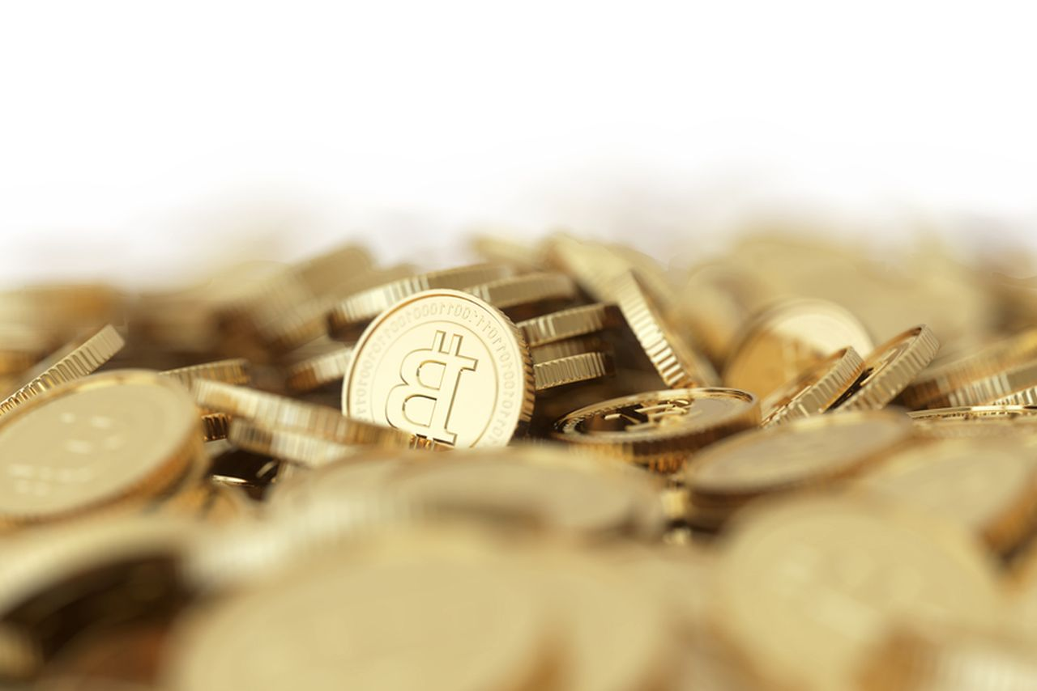
The deposit boxes are like public keys (addresses). Everybody can see the number strings that make up the keys, and, therefore find out how much Bitcoin they hold. But the actual key to each box is the non-public key held by the owner, so only they can open the box.
In our earlier example, Alice sent Betty a message that only Betty could decipher. Bitcoin works a similar manner, except with Bitcoin, we aren’t securing and decrypting letters, but instead the rights to access and move funds between deposit boxes.
Let’s look at another example to better explain how it works:
Alice needs to send one Bitcoin to Betty, so she sends out a message to the whole network. This message includes Betty’s public address (the location of her deposit box and how much Bitcoin is in it), the amount of Bitcoin she needs to send to Betty, and her encrypted non-public key that acts as a digital signature to verify that she is the rightful owner of her particular deposit box.
When Alice sends this message out to the network, lots of different network users take a look and verify that this message is correct. If all the numbers match up, then a record of the transaction is placed into a block (a collection of many transactions). The block eventually gets added to the Blockchain once it is filled with verified transactions.
When that happens, it is a signal that the entire Bitcoin network knows and agrees that Alice’s safety deposit box contains one less Bitcoin than before, and that Betty’s safety deposit box now has one extra Bitcoin inside.
Since the Blockchain is a public ledger that contains records stretching all of the way back to the first Bitcoin transaction, and transactions are never removed from it, then the Bitcoin network is always aware of the precise quantity of Bitcoins in each safety deposit box.

Mining for Coins
Now you understand how transactions occur in Bitcoin, but you may be wondering where Bitcoins come from in the first place.
Well, remember the part about some network users verifying that transactions are correct, and then capturing them within a block, before sending them to the blockchain to be revealed to the whole network?
The term used for this processing of Bitcoin transactions with a computer is ‘Mining’. But mining uses a lot of computing power which needs valuable hardware and expensive electricity. So why would anyone want to get involved with such a process?
Precicely because they are rewarded with Bitcoins for doing so!
Miners verify transactions, and as they are doing so, they are also searching for the answer to a mathematical equation set by the network. The equation is actually unrelated to the transactions being processed, it is simply a way to test the amount of work being done.
If a particular miner is the first to solve the equation, then the Bitcoin protocol allows them to publish their block of transactions to the rest of the network. Whomever publishes a block gets a gift from the network of a set number of freshly minted Bitcoins. This gift is known as a ‘reward’.
The amount of Bitcoins contained within each reward halves every couple of years, so the number of Bitcoins never grows too quickly. Also, as additional individuals come onto the network and add their computing power, the protocol makes it more difficult to solve equations and obtain a block reward. This means that the amount of mining that needs to be performed to create the same number of new Bitcoins is always increasing, so the Bitcoin rewards have to be shared with more and more people.

A Chain of Blocks
If you recall, we discussed earlier the fact that all blocks are eventually chained together into a huge ledger known as the Blockchain.
So let’s look at that chain of blocks in more detail now:
It is imperative that the network possesses a complete, nonstop, running account of all transactions that have taken place; without such a record, mistakes would be made concerning the amount of funds in each wallet.
Thankfully, Bitcoin has a block-chaining mechanism that was designed with this in mind:
Each and every block consists of its hash list of transactions, plus two additional components. The first of these is a condensed snapshot of all previous blocks in the Blockchain, somewhat confusingly also referred to as a ‘hash’. This particular hash helps ensure that new blocks are ready to be perfectly attached to the previous blocks in the Blockchain by providing new blocks with ledger information stretching all the way back to the Genesis Block.
The second additional component is the answer to that sophisticated mathematical problem that miners attempt to solve. This ensures that blocks cannot be attached to the Blockchain before they have been properly validated because each block cannot be mined until the matter has been solved, and if it has been solved then it must also have been validated.
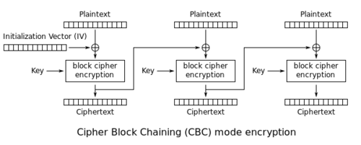

The fact that the blocks contain these components is what keeps the Bitcoin ecosystem alive. Transactions are compiled into new blocks, miners are rewarded for their work. Each of the blocks is sent to the Blockhain for everyone to see, and people make use of the Blockchain record to make new transactions, so the cycle begins again.
As of 2016, there are over 400,000 blocks making up the Bitcoin Blockchain.

Network Verification
So how is it that this system is unbreakable?
Let’s imagine that Alice has no Bitcoins in her account but tries to tell the Bitcoin network she is sending 5 Bitcoins to Betty. She is welcome to attempt this dishonesty, but it would be virtually impossible to get the network to believe her.
This is precisely because Bitcoin’s Blockchain is available to all computers operating on the network, so everyone knows whether anyone else has the right to make a transaction, and all new transactions must be subsequently validated by the network.
If Alice did try send more coins than she had, the recipient would instantly check her balance, acknowledge the insufficient funds, and reject the transaction. That transaction would never be allowed to take its place in the block, and subsequently the Blockchain.
So it is clear that the remainder of the network would never be fooled. Basically, the network remains clean because only verified transactions can ever enter the Blockchain cycle.
By the way, the first verification stage is embeded within the Bitcoin code itself, so it works almost instantly.

How to Acquire Bitcoin
So, you are probably sold by now on the advantages of the Bitcoin ecosystem, and want to own some coins, great! But you are also probably wondering how to go about getting them.
Before we get to that, please understand that you need to know the proper way to securely store Bitcoins before you purchase them. Your Bitcoin wallet is only as safe as you make it, and in later chapters we will discuss the various ways to use the network securely, so make sure you read them before you rush out and start buying coins.
But back to how to actually do it. Well, there are several different ways to get Bitcoins, and in the next few chapters we will take a look at each of them in detail.
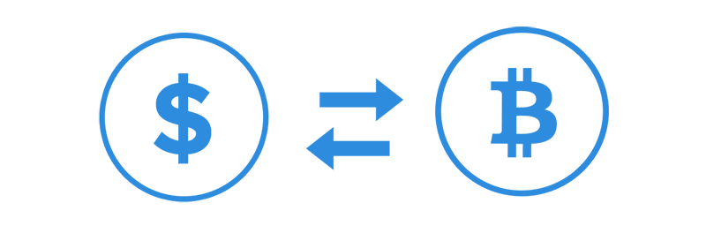
The four main ways are: Being given them for nothing, exchanging goods or services for them, exchanging other currencies for them, or mining them.

Digital Faucet: Free Coins
Yes, there is a way to get free Bitcoins called a ‘faucet’!
Faucets are websites that provide free coins to encourage new Bitcoin users to get started. Once upon a time, faucets gave out tons of coins that would be worth thousands of dollars exchanged today.
But don’t get too excited! Unfortunately, since Bitcoin’s price has risen, the amount that these faucets now pay for each visit is extremely low, and some have closed altogether.
However, they are still worth a visit if you just want some currency for testing out your Bitcoin wallet.

Sell Your Stuff
You can sell goods and services in return for Bitcoin. There are online auction websites like Bitify, and people often search Craigslist for the term “Bitcoin” to find sellers who accept it. Web forums also exist solely for Bitcoin users to buy and sell their merchandise, one of the most well-known of these is Reddit’s Bitmarket.
So if you have something valuable that you don’t mind parting with, it is not difficult to find someone willing to give you Bitcoins in exchange for it.
There are even some examples of high-ticket items that have been sold for Bitcoin:
An American family sold their porsche for three hundred Bitcoins, and a Canadian man traded his house for a quantity. But the most expensive purchase is believed to have been a villa on the tropical island of Bali which sold for over $500,000 in Bitcoins.

Purchasing Bitcoins
The most common way to acquire Bitcoins is by purchasing them for fiat currency. There are various ways to go about this, but let’s consider the two most popular:
The first is to buy Bitcoins locally or via a messaging service, directly from another bitcoiner. Avid Bitcoin users are often very happy to sell small quantities of coins to new users to encourage them to get started.
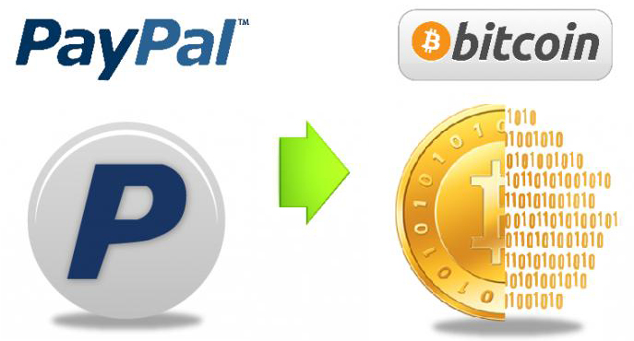

However, you may not know anyone local to buy Bitcoins from. So websites like LocalBitcoins exist to help you find sellers in your area and agree upon a price.
But these personal transactions do carry some risk, because you have no guarantee that a seller will send you the coins after you fork out the money (or vice-versa!).
The way that LocalBitcoins and many other sites get around this problem is to make use of a reputation system similar to EBay’s, where every buyer and seller can leave reviews about transactions with each other. In such a way, anyone else seeking to trade with a person can read reviews about them, and so it is in sellers’ interests not to cheat people, or they might get poor feedback.
But even with such a system in place, cheating can still occur, and you should watch out for ‘selective scammers’. Yet the overwhelming majority of Bitcoin users report positive transaction experiences when trading with services like LocalBitcoins.
The second path to acquiring Bitcoin is perhaps the commonest of all, and this is purchasing them from an exchange, or a Bitcoin payments processor.
Exchanges facilitate business between people who want to trade Bitcoin for fiat currencies, like dollars, pounds, euros, or yen, or for other cryptocurrencies like Litecoin or Ether. Exchanges have been an essential factor in the growth of the Bitcoin ecosystem.
Back in the early days, the original miners just traded Bitcoins amongst themselves, since back then there was not much of a marketplace to sell their coins. But once demand increased and exchanges became fashionable, they began dumping them on exchanges in vast quantities, and Bitcoin became much more widely available to those people who could not afford a powerful computer to mine coins with.
There are many different Bitcoin exchanges out there. Some are big exchanges that are highly trusted in the community, while others are smaller exchanges that are just starting out, or cater to a niche demographic.
Here is a quick overview of some of the more well-known ones:

Mt. Gox. Mt. Gox no longer exists, but is worth mentioning because of its fundamental importance to Bitcoin history, and because its name will still often come up in conversations between bitcoiners.
Mt. Gox was the first and largest Bitcoin exchange for many years. At one time their trading floor accounted for almost 100 percent of the entire Bitcoin trading industry.
Mt. Gox began to seriously decline by 2013 as other exchanges came onto the market and they began to use suspect business practices. However, they were still the largest exchange when they folded and declared bankruptcy in 2014.
Their bankruptcy and subsequent refusal to pay out user’s Bitcoins had such a massive effect on the Bitcoin ecosystem that it entered bitcoiner mythology. Even today, the slang phrase ‘to be goxed’ is still used in Bitcoin circles to mean that a person or organization is withholding coins belonging to somebody else.
CampBX. Is a large US-based exchange, where Bitcoins are mainly traded against the US dollar. CampBX became successful because it accepted dollar deposits from payments processor Dwolla.
BitStamp. Is a massive exchange based in Europe which handles multiple currencies. Since the demise of Mt. Gox, it has become the largest Bitcoin exchange and Bitcoin payments processor.
Coinbase. Was opened 2012 and is based in California. It allows you to link your checking account and use it to purchase Bitcoins, but there are limits to how many Bitcoins you can buy or sell with their service. Like Bitstamp, Coinbase has grown very large since Mt. Gox is no longer around.
BTC-E. Is an Eastern European exchange dealing in many different traditional and cryptocurrencies, including Bitcoin. BTC-E is a well-known and respected exchange despite having a very underground feel to it. It is perhaps most famous for its ‘troll box’, an online chat room that allows traders to shout various messages to one another while trading.
BitInstant. Is a little like Coinbase, but you do not need a checking account. Instead, for a fee, you can deposit money at certain US stores like CVS or Wal-Mart who have a deal with BitInstant. They will process your payment and you will receive Bitcoins in minutes.
Despite there being all of these ways to get Bitcoins, it usually takes a fair amount of patience before newcomers finally work it all out and manage to get some coins into their wallets.
Due to a clampdown on Bitcoin trading and emerging international laws, a lot of exchanges have recently begun to require identification before you can cash out, or fund an account. Unfortunately, their method of verifying who you are can often take days or even weeks.
So, which exchange you ultimately choose can often depend upon your level of patience, what fees you are willing to pay, and how much a trusted name is important to you.
If you are patient, only willing to pay a low amount in fees, and do not mind your coins being tied to your identity, then Bitstamp or Coinbase would be good choices.
They are fairly easy to sign up for initially. You just need to register an account with an email address, and link up your checking account. You may also link your online banking service. The only problem is the length of time these services require for verification, and that you need a passport and a letter from your home address. But at least they are trustworthy.
However, if you are impatient and need Bitcoin right away, then services like BitInstant are a better choice, assuming you can tolerate the higher fees. The company certainly lives up to its name and coins are delivered very quickly to your wallet. It is not difficult to find stores to deposit your fiat currency at either, and there is sure to be one in your neighborhood if you look around. The problem with this is that you still need to submit your personal data, so BitInstant-style services are not anonymous.
If you just want to jump into the thick of hardcore trading, have some laughs, pick up some bitcoiner slang, and feel the excitement of trading the way it used to be done back in the early days, then go to BTC-E.
If you would like to remain in the shadows, then you should use Local Bitcoins to interact with a peer and make a deal directly with them. Of course, the downside is that you risk being scammed. So make sure to check that the sellers you choose to buy from have a lot of positive feedback before you go ahead with any trade!
Unless you know the person, you should be terribly cautious of anyone trying to sell you Bitcoins outside of safe environments. For example, if you meet a person on a Bitcoin forum who wants to sell you Bitcoins via PayPal then alarm bells should start ringing in your head. PayPal is a bad way to buy or sell Bitcoins because transactions are reversible, which means somebody may receive coins and then take back their payment.
You should always do your research regarding exchanges and other services. Use Google to check out companies you are unfamiliar with and eventually you will work out what is best for you. But remember to learn how to secure your coins before you buy anything!

Mining for Bitcoins
So finally we come to the last and most famous way of obtaining Bitcoins, which is to mine them. Your head may already be filling up with wild dreams about mining millions of Bitcoins with your laptop or Android phone, but for most readers Bitcoin mining is unfortunately no longer feasable.
As previously mentioned, Bitcoin mining involves using computer power to process the transactions of users on the Bitcoin network while looking for the answer to a mathematical equation. The first miner to find the answer is allowed to publish the block that they solve, and receive a twenty-five Bitcoin reward in return.
Twenty-five Bitcoins created every ten minutes is quite a lot of money, so why aren’t we all mining Bitcoins?
Well the bad news is, that the Bitcoin mining ship has already sailed. It is now unlikely that any average person could profit from Bitcoin mining considering the amount of time, computing hardware, electricity, and money it takes to build a mining rig capable of solving blocks today. There is simply too much computer power already being thrown at the network.
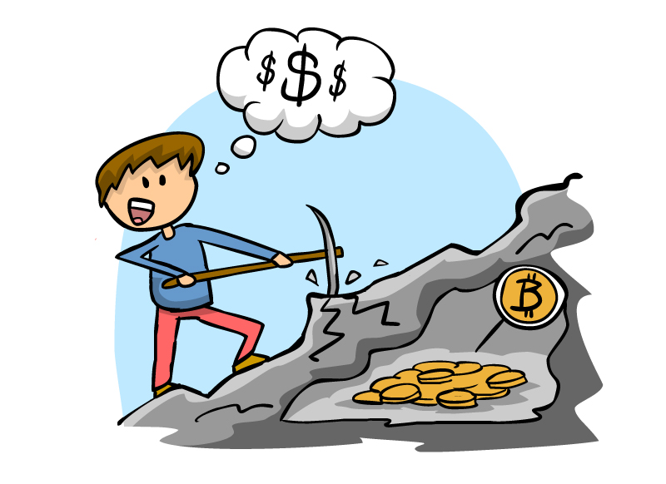
If that is true, then what is going wrong, and why are there so many miners out there still keeping the network going?
Well, in the early days of Bitcoin, miners could use the CPUs on their home PCs to mine Bitcoins. But remember that the protocol is designed to increase the mining difficulty in proportion to the amount of mining taking place on the network. This is not a flaw. It is done to restrict the number of Bitcoins being released into the market.
One day, some clever person realized that using a GPU (graphics card) instead of a CPU would allow them to solve each mathematical equation very quickly, because GPUs are better at crunching the kinds of numbers used for the equations. So this person mined a fortune in coins in a very short space of time. After that, everyone else caught onto the idea and began building massive computer rigs dedicated to mining with multiple graphics cards installed.
The rigs grew in size and scope until they began to fill whole rooms, and lots of people began to race with each other to build the biggest rigs and mine the most coins. This became known as the Bitcoin ‘arms race’, after the nuclear arms race between the Soviet Union and the USA during the cold war.
Because of the ridiculous nature of this arms race and the fact that so much processing power has come onto the network, the Bitcoin protocol now makes it extremely difficult for anyone to obtain a block reward.
Miners first worked around this problem by creating mining pools. A mining pool is a website that allows small-time miners to pool their resources to make themselves more powerful in the arms race. They team up together and contribute CPU power, then, if the pool manages to solve a block equation, the proceeds are divided proportionately among everyone in the pool.
Mining pools worked OK for a while, but now the Bitcoin reward difficulty has ramped up so much that a commercial PC would only make a few cents per hour as a member of a pool.
Once the arms race participants had exhausted the scope of their graphics cards, they began to put some of their profits into finding out the next big thing. What they came up with were Application Specific Integrated Circuits (ASICs), designed from the ground up for Bitcoin mining.
ASICs do much more work, are easier to keep cool and use far less electricity than even the best graphics cards, so they were a big step forward for miners. However, they cost a lot of money to purchase, a high-quality ASIC mining rig can run into the tens, or even hundreds of thousands of dollars. Additionally, even if you bought a decent ASIC miner, you would always be competing against a guy who already has ten of them, or twenty, or a hundred.
This is what stops most newcomers trying to enter the mining business. The chances of getting a block reward are now so low, and the electricity, equipment, and maintenance costs are so high, that you would probably be better off taking those thousands of dollars and buying Bitcoins directly!
So, it is not a good idea to mine Bitcoins anymore. It has become a specialist industry only open to larger players with access to the infrastructure and Sadly, the days when running mining software on your laptop would net you a small fortune in Bitcoins are long behind us.

How to Accept Bitcoin, For Small Businesses

This section is designed to help all of the small business owners out there who want to know how to accept Bitcoin as payment for their goods and services.
It is written with the idea that you already operate a relatively small everyday firm trading goods and services for normal fiat currencies like dollars. It is also assumed that you would like to simply accept Bitcoin as additional payment method, and that, for tax purposes you will record your Bitcoin financial gains like any other.

Starting to Settle Transactions for Bitcoin
Bitcoin acceptance at small businesses is best done in whichever way keeps the accounting easiest for you. This may vary depending on what kind of operation you run.
Start with a Sign
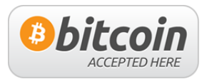
If you still think the Bitcoin market is tiny, then you can test your theory by simply posting "We Accept Bitcoin" on your website. Undoubtedly, you will soon find that a great many people will contact you to use the payments system.
You see, Bitcoin is based around a complex ideology. If you post such a message, many people will see that you are increasing awareness about Bitcoin, and will support you. They also will feel that you are setting a precedent for accepting the currency that others will follow in the future.
So it is likely then, that when you post the message to your website it will be shared around the Bitcoin community, on forums, lists and podcasts. Many new people will find out about your business and visit you to spend their Bitcoins, so mere acceptance of the currency is already great free advertizing.
Utilize a Merchant Solution
If you sell goods or services on your website, you’d be best to use a Bitcoin merchant solutions company to accept the Bitcoins. A merchant solutions company provides things like stores and shopping carts, or payment buttons, so that you can easily integrate them to your website. Then when somebody buys something, the merchant solutions company accepts the Bitcoins on your behalf and pays their value back to you later, minus a fee.
If your business operates from a traditional bricks and mortar premises, then you will need to invest in hardware terminals, mobile app integration or a QR code reader.
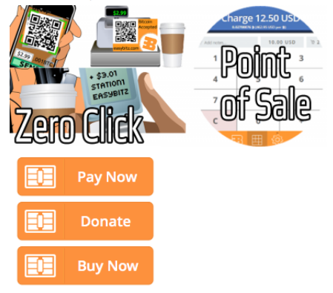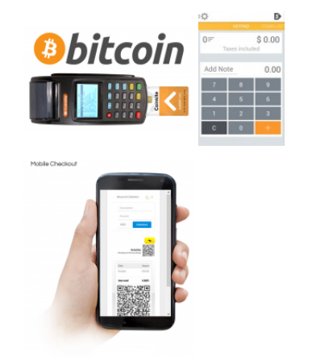

Smart Phone or Tablet
You can take payments from a wallet address with any QR code reader. It is usually best to place the QR code reader close to your cash register so that shoppers can scan with their phone and pay easily. For convenient settlement, you can get web apps that generate QR codes on the fly from wallet addresses.
Point-of-Sale Hardware Terminal
With custom hardware, you'll be able to integrate your existing cash registers and POS solutions.
Accounting
When a client makes a payment, you may accept it like regular money. But you might want to encourage more Bitcoin use at your store. One way to do so is to give customers a discount for using Bitcoins. However, you might want to ensure that this is financially viable or you could end up losing money. But if you are giving discounts for using Bitcoins, then it is likely that many Bitcoin users will flock to your store and create overall financial gain for you. This will also raise your businesses’ profile and standing.

Avoiding Fraud
There is a risk that fraudsters might create counterfeit invoices under your company name and send them to your customers. This would be to attempt to get them to send payments their Bitcoin address rather than yours.
The risk of this happening depends upon what sensible precautions you take against it in the first place.
First of all you should never print off whole Bitcoin addresses on receipts, instead, you should only make this viewable from your website via a secure SSL transmission. However, you can still print most of the address on the payment stub (with most characters blanked out), so that customers can have a written record of the transaction should there be a payment dispute.

Setting Prices
When a business accepts Bitcoins for payment, they usually need to convert them back into traditional currency in order to pay suppliers, staff, and shareholders.
The Bitcoin price can be tracked against several currencies on multiple exchanges, so many merchants link the price of their items in Bitcoins to the market value of Bitcoin at the time of the sale.
The price of items can be determined on either a current Bitcoin to fiat exchange-rate basis, or on an average Bitcoin price to fiat exchange-rate basis.
Bitcoin Charts provides a data feed that gives current prices from specific exchanges, while Bitcoin Average offers a feed that averages its results from snapshots of Bitcoin’s value across all of the world’s exchanges. They also offer a twenty-four hour sliding average indicator to keep everyone informed of Bitcoin’s value by way of an easily-accessible API.
Once Bitcoin funds are received, many merchants instantly exchange them for fiat currencies. Exchanging Bitcoins immediately after every deal will almost eliminate the risks merchants face when holding a volatile currency like Bitcoin, because the currency will not have a chance to lose value before they are exchanged. However, the currency will not have chance to gain value either, so some merchants might want to hold onto them if they think they can make a profit.

Contracts
Sales contracts can be customized to make sure customers are aware of specific terms and reduce the possibility of any misunderstandings. For example, if the party making payment is to be liable for paying any necessary service fees, then the contract should specify these. It should also account for the reasons the fees are to be paid and their quantity, plus specify what will happen if there is a disagreement.
Here are some other things that may need to be addressed by a sales contract:
• The requirement for reading and accepting the contract before using a specific service.
• The dispute method and its jurisdiction.
• The company’s refund policy.

Paying taxes on Bitcoin gains
Tax compliance is always a topic of concern for small businesses.
But in several respects, Bitcoin transactions can be treated a lot like hard cash transactions, because although cash is anonymous and does not leave a written record either, it is nevertheless widely used in daily commerce. So you are often best off using the same method you use to record your hard cash transactions to record your Bitcoin transactions.
But how can you record how much you have earned in Bitcoins in a way that the tax authorities will accept?
Well that depends on the jurisdiction you live in. So you should always phone for advice from your local tax authority. Some jurisdictions might require no reporting of Bitcoin sales, while others will require reporting, AND extra tax!
However, most tend to expect you to record sales made in return for Bitcoins in local fiat currencies, at the value the Bitcoins were worth when the item was sold, and to record income from Bitcoins sold at the amount in local fiat currencies that they were sold for.
This situation is not unlike what would be expected when accepting any other foreign currency as payment. So, record the dollar value of Bitcoins when they are received, record the price you sell them for when they are cashed in, and also record any changes in value that has taken place in the meantime. This should ensure that you have enough information to satisfy the tax authorities if they come asking for it.

How to Store your Bitcoins
You know now that Bitcoin is a digital equivalent of money, and that new merchants begin accepting them as payment every day. You also know how they are generated, and the way a Bitcoin transaction works. But now you are probably wondering how best to store them.
In the physical world, we tend to store our cash in a physical wallet. Bitcoin is also stored in a wallet, except that it is a digital one.
A Bitcoin wallet is a software file containing your private-key, public-key (address) and your balance. Wallet files are loaded into wallet software so that they can be used. Wallet software is available in numerous forms, and for various devices. Of course, it is always important to secure and make backup copies of your Bitcoin wallet files, and you can even make paper wallets if you do not wish to store your coins on a computer.
However, to be technically correct, you do not store Bitcoins anywhere. What you store in the wallet, are the secure digital keys used to access your public Bitcoin addresses and sign transactions.
Bitcoin wallets are available in various different forms. The five main types of Bitcoin wallet are: desktop, mobile, web, paper and hardware.

Desktop Wallets
If you have already installed the Bitcoin Core software from the Bitcoin.com website, then you are running wallet software, perhaps without even being aware of it. In addition to relaying transactions to the Bitcoin network, Bitcoin Core also allows you to create a Bitcoin address for receiving coins, and to store the personal key for it.
There are other desktop wallets too, each with their own unique features. Multi-Bit runs well on Windows, Mac OSX, and Linux. Hive is an OS X only wallet available on the App Store to connect you to Bitcoin services.
Some desktop wallets like Armory are geared more towards increased security. Others like Dark Notecase work in conjunction with a browser plug-in to deliver services like coin ‘mixing’, in which Bitcoins are tumbled together with those of other users so that they cannot be easily tracked on the Blockchain.
Normally, desktop wallets need to download every single byte of the Blockchain (which can run into several gigabytes), before they can work. This process is called synching, it allows your wallet to keep up with the latest blocks, but it can take several hours if you have not kept it up to date.

Mobile Wallets
Carrying around huge Blockchain files is not terribly useful when you are out on the road, or trying to buy something at a physical store.
That’s when a mobile wallet comes in handy. They tend to come in the form of an app for your smartphone, and in addition to storing the personal keys for your Bitcoin addresses, they allow you to buy things with your phone directly.
Mobile wallets are not quite the same as fully-fledged desktop wallets because they do not need to download the entire Blockchain in order to work. That might save you a whole heap of hassle with your mobile service supplier, who would be only too happy to send you a hefty bill for downloading it over a cellular link. In any case, most phones would be unable to store the entire Blockchain in their limited memory.
In some cases, a mobile Bitcoin wallet can even make use of your smartphone’s near-field communication (NFC) feature, enabling you to hold the phone against a reader and pay for something with Bitcoins, without having to enter any data manually.
Mobile wallets are also usually designed with simplified payment verification (SPV) in mind. This works by transferring a small amount of the Blockchain and rely upon various trusted computers (nodes) within the Bitcoin network to access the data they need.
Examples of well-known mobile wallets include: Mycelium, Xapo and the somewhat confusingly named Blockchain (which keeps your Bitcoin keys encrypted on your phone, and saved on a web-based server).
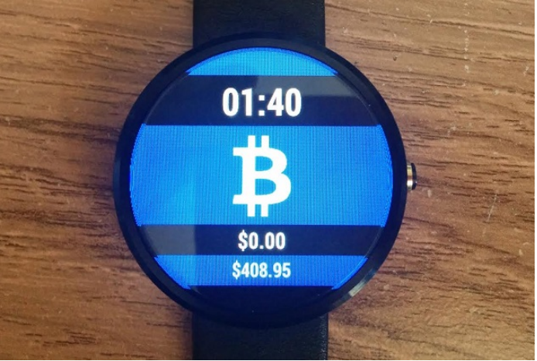
There are also browser-based mobile wallets from Coin Punk and the Aegis Bitcoin wallet for Golem smartwatches.

Online Wallets
Web-based wallets store your personal keys on servers connected to the internet. There are many web-based wallets out there. Most are also able to be integrated with mobile and desktop wallets, so they allow you to access your wallets across the full spectrum of your devices.
The good thing about web-based wallets is that you can access them from anywhere, so you do not have to sit at your desktop all the time. And you do not need to sync to the Blockchain either, so they are always ready for you to send and receive coins.
However, they have one major disadvantage: They require your personal keys to be placed under the control of whatever organization owns the web-based wallet service, taking your Bitcoins out of your control and involving a third party. That defeats the purpose of Bitcoin in the first place, and could be a scary thought, especially if you start to accrue large quantities of Bitcoins.
Coinbase offers a web-based wallet service, and users in the US and Europe can also conveniently stock it through the company’s exchange.
Circle Financial offers its web-based wallet to users worldwide for storing, sending and receiving Bitcoins. It allows you to send coins like emails, texts and instant messages, and you can also purchase them from the company directly.
Blockchain hosts a very well-liked and well-known web-based wallet, and also provides a Blockchain analysis platform that is really easy to understand.
Strongcoin offers what it calls a hybrid wallet, which for security purposes enables you to encrypt your personal keys before uploading them to its servers, while Xapo aims to combine the convenience of a web-based wallet with the extra security of a cold-storage vault.

Hardware Wallets
Hardware wallets are dedicated hardware devices, almost like USB drives which will securely store your personal keys and facilitate payments.
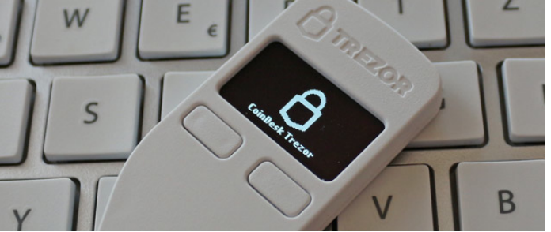
Trezor Hardware Wallet
The Trezor hardware wallet is a well-known example, catering primarily to bitcoiners who want to keep a considerable stash of coins. It is very secure and suitable for anyone who does not wish to rely on third parties or use other impractical kinds of cold storage. But is also fairly expensive.
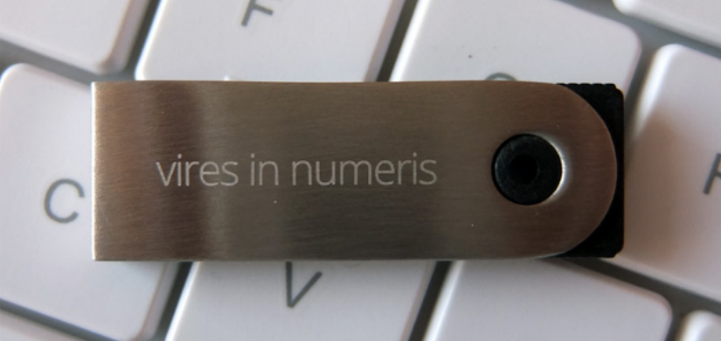
Ledger Smart wallet
Ledger produces a compact Bitcoin wallet that uses smart-card access points on your PC, and is available for a fairly low price.


KeepKey wallet
The KeepKey wallet was originally based on the Trezor wallet code and costs around the same price. It has a very attractive design, integrates with web browsers and has a cool looking digital display.
Mycelium, and BitStash are companies that are currently developing hardware wallets too, but, as of 2016, neither has released a product.

Paper Wallets
One of the most secure and cost-effective choices for keeping your Bitcoins safe is a paper wallet.
There are many websites out there providing paper wallet services. These sites will generate a Bitcoin address for you and use it to create a special image containing two QR codes: one is the public address that you will use to receive your Bitcoins and the other is the personal key used to send Bitcoins from that address.

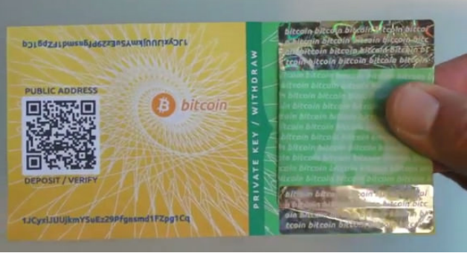
The good thing about paper wallets is that their personal keys are not stored digitally, and so cannot be subjected to cyber-attacks or hardware failures.
However, the bad thing about them is that they might be damaged in a fire or flood, you may lose them, or someone might steal them from your pocket, and there is no backup!

Securely Storing your Bitcoin
The final topic to cover before you go experimenting with Bitcoins is secure storage. This can be one of the most intimidating aspects concerning Bitcoin, because if you mess it up, you might lose your coins for good. Storing your Bitcoins securely does require some technical ability but it is not overly complicated.
It is not advisable to skip this topic, because not securing your funds correctly is like leaving the doors and windows of your house unlocked while you go out, and just hoping nobody decides to come in and steal something.
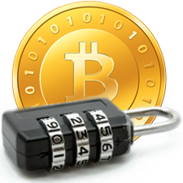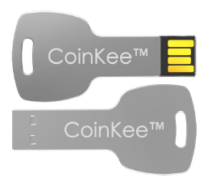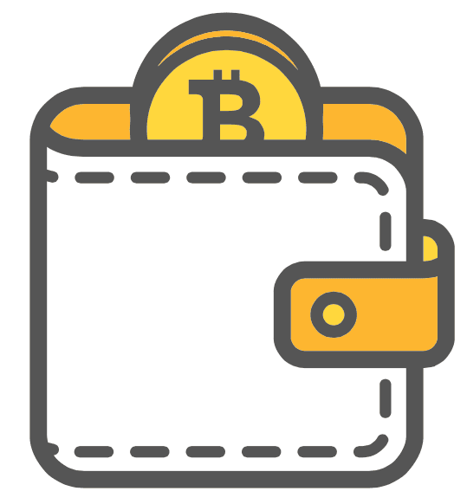

First, let’s clear up a misconception you might have. You could have heard many people saying that Bitcoins are stored in wallets, but this is actually just a manner of speech and not literally true.
The coins are literally in their deposit boxes (their public addresses) up on the Blockchain, and a wallet is just a file with all of the information about your deposit boxes into one place so you can gain access to them.
Think of a wallet as your own little bank. With it you can look at your row of deposit boxes, and you have the keys to those boxes too. So, whenever you want to look inside, remove, or add Bitcoins to any of your public addresses, the wallet allows you to do so.
But this wallet is just a file full of cryptography and code. You need a way to read and operate it, and this is where wallet software comes in.
Let’s look at just some of the many different varieties of Bitcoin wallet software:

Bitcoin-Qt: The Real Deal

The first variety is the original wallet. This is the PC program (client) that the core developers working on the Bitcoin code have released.

The Bitcoin client is regularly updated and is high quality. It requires that the complete Blockchain is downloaded onto your PC, and as mentioned earlier it consists of many gigabytes.

The official wallet has some advantages:

- When you are running the program, you become a node within the Bitcoin network. So you are doing your bit to keep the Blockchain healthy and decentralized.

- You are not trusting any third party with your non-public keys since they are stored locally on your computer and not anyone else’s. Even the Bitcoin Core developers cannot see them.

- You are using the wallet software code that is the most secure because it is the most reviewed. If anyone were to try and corrupt the Bitcoin-QT with, let’s say a virus that could steal your coins, then the world would immediately know about it because the software is open source and constantly peer-reviewed.

There are also some disadvantages:

- Downloading the complete Blockchain takes an awfully long time (hours or maybe even days depending upon your internet connection). It also requires a computer with a large hard drive.

- If you encrypt your wallet, then forget your passphrase, your coins can not be retrieved.

- You are connected to the internet, increasing the possibility that somebody could steal your passphrase or your wallet file.

- You can only access your coins from the PC that holds the wallet.

While Bitcoin-Qt is certainly a solid wallet option, it is probably no longer suitable for Bitcoin beginners due its lack of ergonomics and the length of time it takes to sync with the Blockchain.

Modified Wallet Software
There are some wallets that are standalone programs, like the Bitcoin-Qt, and are often based upon its code. However, they are modified to include additional features.
Here are some examples:
Multibit is often thought of as a ‘lightweight’ wallet since it does not require you to download the complete Blockchain and uses far fewer system resources. Syncing is much easier and faster compared with Bitcoin-Qt. So, for novice users who need a standalone program as their wallet, Multibit can make for an excellent choice.
Electrum does not require any of the Blockchain at all. Instead, it connects to an overseas server, so requires no time to set up for use. It also allows users to choose a ‘seed phrase’ when they first open the wallet. This seed phrase can be used to recover coins in the event of a broken hard drive or lost password.
Armory is incredibly secure and extremely feature-rich. It allows users to make a ‘cold-storage’ backup wallet for extra security and has all the bells and whistles a wallet user would ever need.

Accessible Anywhere: Online Wallets
You do not need a standalone program on your PC to use Bitcoin. Instead you can use a website that allows you to secure your Bitcoins in an easily accessible online wallet.
Internet-based wallets have some advantages:
- No syncing is necessary, your Bitcoins are instantly accessible.

- They can be accessed from many places other than your computer; all you need is an online browser.

- You can integrate your wallet with browser plugins that make using Bitcoin online much easier.

- Your coins are not held on one single hard drive, so if your PC crashes, they will remain safely in the cloud.

But they also have some disadvantages:
- You must trust a third party with your Bitcoins. While many online wallet service providers have a good name, it is still always risky to let another party hold onto your non-public keys.

- If you are connected to the internet you are already at some risk of malicious attackers who might try to steal your coins. But internet-based wallets are often even more vulnerable to attack.

- Many online wallet services have indeed been attacked and many have closed shop following such an attack, and they have not refunded all of their users.

So should you use an internet-based wallet at all?
Well, for small amounts of currency they can be a very convenient choice. It is much easier to simply log onto a website to move your Bitcoins and let them do all the hard work of syncing for you. It is especially beneficial if you are planning on leaving your home for a few days and do not want to take a laptop. However, these services should not be used for any amount of Bitcoins that you cannot afford to lose.
And which one to use? Companies like Coinbase have wallets designed specifically for their services, and they are usually fine to use. However, Blockchain’s wallet is arguably the best, and is the most popular, because it is well made and has a very good name.

Bitcoin on the Go: Mobile Wallets
You do not actually need a PC to use Bitcoin at all, because most smartphones are capable of installing a wallet app. These apps do not need to download the Blockchain in its entirety and are about as secure as web-based wallets.
There are lots of Bitcoin wallet apps available for Android. Simply search for ‘Bitcoin Wallet’ in the app store. But check out the reviews, and only use wallets that are considered genuine and good.
Apple iOS also has many wallets available in their iTunes Store. These have gone through Apple’s stringent quality control processes, so should be pretty professionally made.
So should you use a mobile wallet?
Well, there are always those times when it is preferable to use one. It can be fun to take Bitcoin with you wherever you go, and if you discover a business that accepts them, you can think about buying a little something as a show of support!
However, like with web-based wallets, you should never carry lots of Bitcoins in a mobile wallet app.

More about Paper Wallets
Some people do not want to use laptop, internet or smartphone-based wallets. Instead, they want to go back to basics and use paper.
But you are probably wondering why on earth anyone would want to keep digital coins on paper. Well, there is an easy answer: Paper wallets are by far, the safest method of storing your Bitcoins. So if you do not need to use your coins regularly, and just want to store them long term, then you might want to look into using a paper wallet.
You might wonder how it is possible that Bitcoin, a digital currency can be stored on something as primitive as a piece of paper. But remember that the genius of Bitcoin lies in public-key cryptography, and its public ledger, the Blockchain.
So, to make a paper wallet, all you have to do is create a public Bitcoin address, place some Bitcoins within it, and then print off the non-public key and store it somewhere safe.
To use your Bitcoins later, you would find your piece of paper and input the non-public key from it. Often paper wallet generators print this as a QR code in the first place, so you may only have to scan the non-public key.
While the method is easy enough, it gets harder to create a paper wallet with a completely secure approach. We will cover that later, once we have discussed why correct storage is vital.

The Threats
So, you have an idea of the various ways to store your coins, but is there really a need to keep them safe?
Yes there is!
There are many threats to your digital cash, and being attentive to them will greatly increase your chances of avoiding them.
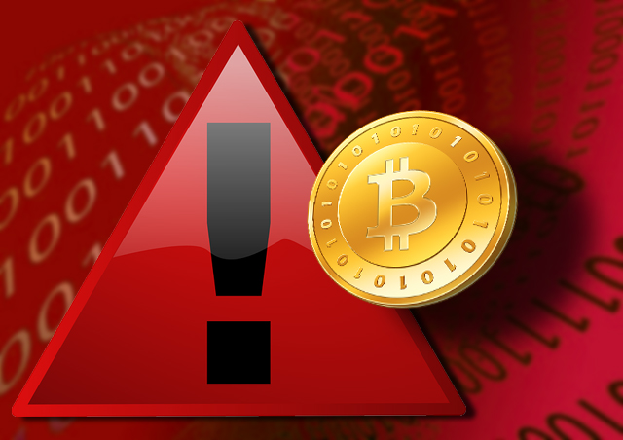

Yourself
You are the biggest threat to your coins. That might sound strange, but it is true.
There are a great many horror stories of individuals being careless and losing their Bitcoins, and it is usually one of two major mistakes that they tend to make: The first is to encrypt their Bitcoin wallet and then forget the password, and the second is to leave their wallet on a hard drive which then breaks, causing it to be lost forever.
Most of the standalone Bitcoin wallet programs allow you to encrypt your wallet file. This is sensible, and you should do it, because it stops people accessing your PC and getting to your coins.
However, many people make the password and then forget it because it could be months later when they come to access their coins again. And if this happens to you, you are sunk, because there is no way to recover those coins (no, none at all…ever!).
When you choose a password you must write it down and put it in a safe place. This is even truer if you have multiple wallets, don’t use your wallet often, or use web wallets.
It is easy to deal with the problem of hard drive failures too. All you need to do is make copies of your wallet file and save them to a USB drive, or a web storage system like Google Drive or Dropbox. If you are going to make a backup, then encrypt it but write down the password first.
By the way, make sure you put your written password and backup copies in a safe place!

Physical Theft: Roommates and ‘Friends’
Theft is a very common threat all bitcoiners face. Whether you have a paper, mobile, or desktop wallet, there are always ways for a thief to walk off with your coins. If they can access your wallet in any way, then they will transfer your coins to an address they own and you will not even be able to find out who did it.
The obvious thieves are people online in web forums who sound shady and try to get you to give up your wallet keys. It is not hard to see them coming from a mile away. But many bitcoiners suffer theft from people they know!
This might sound harsh: But you cannot trust anyone where Bitcoins are concerned, your housemates, friends, and maybe even your family members can become unrecognizable people when money is involved. Never leave passwords to wallets, or unecrypted wallets lying around, ideally the only person who should be able to access YOUR Bitcoins is YOU.

Active Attacks: Hacking
There are many tech-savvy criminals out there who are making it their business to hijack as many Bitcoins as they can. They primarily target exchanges or online wallets were there are millions of users and lots of coins. Several exchanges have been hacked within the past few years, resulting in many lost coins, and they are seldom recovered or the perpetrators identified.
Luckily, they cannot hack the SHA-256 encryption in Bitcoin itself, so individual users are only in danger when holding coins online with vulnerable web-based services.
As the Bitcoin community and infrastructure grows, it is likely that more professional and mature firms will populate it. They will have the finances and experience to deal with hackers, and to implement much more stringent safety measures. But until then, the best approach is to only store small amounts of coins with exchanges and online wallet providers. Be careful!
Passive Attacks: Malware
Passive attacks are carried out by somehow implanting malicious code on a bitcoiner’s computer. They are a much bigger threat to the average bitcoiner than active hacks because they target an individual’s PC.
The malicious code will often record all of a bitcoiner’s keystrokes, and then send them to the hacker. If the hacker can use a keylogger to find out your password, then he can get at your Bitcoins.
Sometimes the malware in question is a program that can automatically search a bitcoiner’s PC for Bitcoin wallet files, and if it finds one, send it straight to the hacker. If a hacker has your unencrypted wallet file, then he can get at your Bitcoins.
These types of attack will usually get in via a browser when you click some shady looking link and it permits a bad script to run. Sadly, malware like this is very easy to pick up, particularly if you don’t have good protection against it and are dangerous with your web browsing habits.
Try to get a malware protector and stay away from dodgy looking websites and links. Sites that have a lot of popups are usually the worst places for malware.

Avoiding the Risks
In this chapter we will look at more detailed ways to avoid the risks we discussed. Some are straightforward, while others require technical knowledge and some time commitment.
But you first need to decide how safe you want your coins to be. If you only hold a small amount of Bitcoin, then you might not care enough to follow these suggestions. At the end of the day it is up to you to decide how much security you may need.

Have a Clean Software Package
Your operating system (OS) is the main software used to run your PC. There are three major operating systems in use worldwide today: Windows, Apple OS, and Linux.
Windows seems to be much more susceptible to malware than the other two. Therefore, Windows is the riskiest operating system to have a Bitcoin wallet installed on. Apple’s offering is better, but not by much.
However, a Linux system is considerably safer. So if you intend on keeping a large quantity of coins on a PC, then it is probably a much better idea to put it on Linux or some other UNIX-based system.
The learning curve for a UNIX-based OS might put you off if you are used to Windows, but most of them are free and not that difficult to learn. They also have nearly all of the features of their bigger counterparts.
In fact, it might be a good idea to consider getting hold of an old laptop, wiping the hard drive and installing a UNIX system. Doing so will provide you with the maximum amount of security because you can run a completely clean UNIX install. Ubuntu or Mint are good, solid UNIX operating systems to go for. You might find such a device on EBay or Craigslist; just look for something basic and low cost.

Acknowledge that the Internet is Dangerous
The internet is essential to Bitcoin’s operation, but it is also one of the most dangerous environments for your coins. Your computer and the coins on it are theoretically open to attack from anyone in the world. You have a couple of choices if you want to mitigate this risk.
You might choose to operate completely offline by using a paper wallet or offline service (the Armory wallet allows this). Storing Bitcoin offline is known as ‘cold storage’, and is often a no brainer when you have really large quantities of Bitcoin. Obviously, the longer you spend offline, the better, so if you need to check your wallet online for any reason, then make it quick.
If online operations are a must for you, then you will need to work on your PC fastidiously. Use of a UNIX system is preferable, since there are not as many backdoors for hackers to get in by. But if you are married to Windows, then make sure you have some good malware protection. At the very least, get Microsoft Security Essentials, which is free and offers some protection. Keep any protection software updated at all times to stay ahead of the latest threats, but remember that even if your computer scans clean, some malware may have slipped though the net.
Whenever you are browsing the net, remain sensible and aware of where you go and what you click on. This is especially true when downloading files and torrents. Malicious computer code usually gets in via incorrectly labeled download links; so that ‘free’ movie could cost you a fortune in Bitcoins!

Use 2-Factor Authentication
Online exchanges and wallets nearly all provide a service known as 2-factor authentication (2FA).
2FA makes you verify your login details from a secondary source. This is usually done via a code sent to your smartphone as a text, or by using additional software.
A good 2FA app is Google Authenticator which is available for phones and tablets but there are many such apps on the market and most are free.
You should continuously change your 2FA identification credentials. But be careful with 2FA, if you lose the phone or software it is linked too then you will be locked out of your account forever. So sometimes it can cause more problems than it solves.

Spending and Accepting Bitcoin

Spending Bitcoin
So, you have got your coins, and they are safely stored, but what should you do with them? Well, since Bitcoin is digital cash, any transaction you currently make with cash could be made with Bitcoin instead. The only requirement is that the person you want to pay is willing to accept Bitcoin as a payment method.

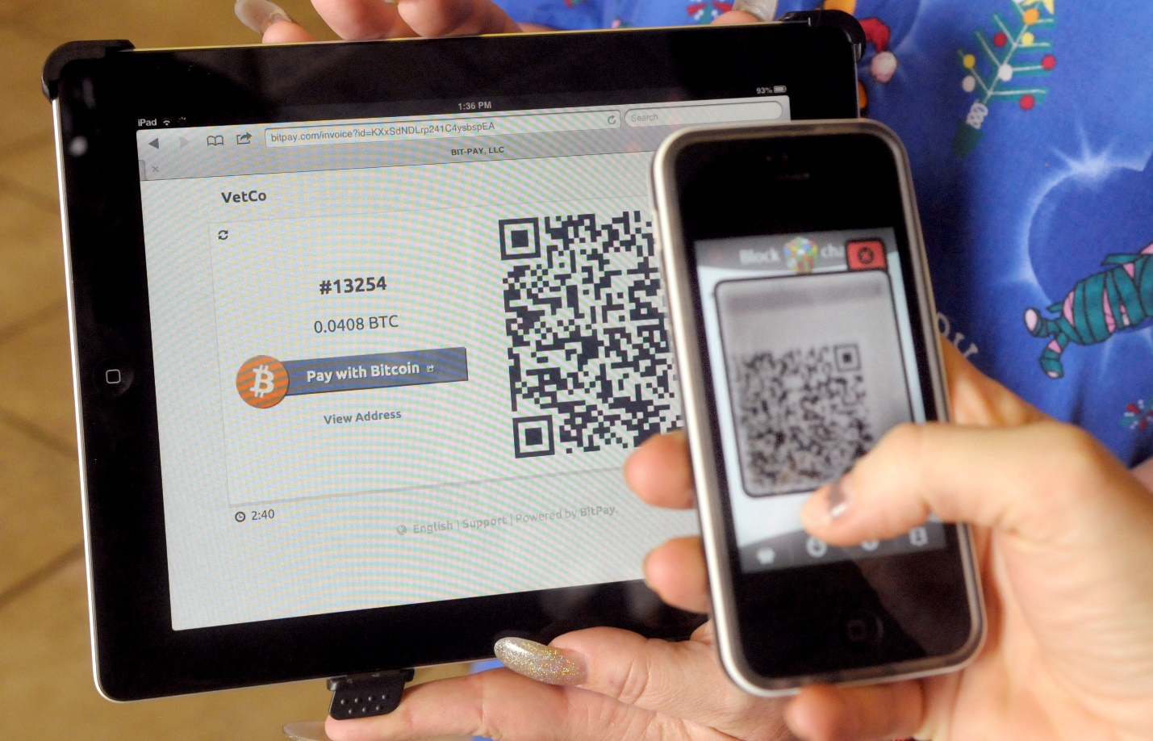
The Bitcoin economy remains a young one, but more and more merchants are waking up to its possibilities every day. And aside from merchants and other businesses, there are many people who try to use the currency whenever they can, rather than using traditional money.
Here are some popular ways to use Bitcoins:
Amagi Metals. A precious metals dealer that will happily settle for Bitcoin.
BitBet. A Bitcoin-based bookmaker that has been in business since 2013.
BitcoinTalk Forum. The busiest Bitcoin forum on the internet. It features a section entirely devoted to buying and selling products and services with Bitcoin.
Bitify. An eBay-style auction house that uses Bitcoins instead of traditional currencies.
Bitmarket. A subreddit community for buying and selling with Bitcoin.
BitPremier. A high-end luxury items merchant that accepts Bitcoin. They sell everything from sports cars to yachts.
Charities. Several charities currently accept Bitcoin, including World Aid and the RNLI.
CheapAir.com. An online flight and travel agents allowing you to pay in Bitcoins.
Craigslist. Search for the term Bitcoin on Craigslist and you will find many people willing buy and sell with the currency.
Dark Markets. The dark web is full of Silk Road-style websites that will sell you anything from drugs to weapons in return for Bitcoins. This book does not recommend that you use these websites, and if you do so you are obviously breaking the law and may be subject to penalties. But nevertheless, they exist.
Dell. You can spend your bitcoins at PC giant Dell.
Foundations. Non-profit foundations who will happily take Bitcoin donations include Mozilla, Wikipedia and many others.
Gyft. Huge online giftcard/voucher company that allows you to buy giftcards with Bitcoins. Gyft is convenient for those times when you want to spend Bitcoins at a retailer that does not accept them. Buy a card from Gyft for that store instead.
Microsoft. You can spend your Bitcoins in return for many of Microsoft’s cross-platform online services.
NameCheap. A domain name registrations company that allows you to spend Bitcoins on web domains.
Newegg. Another huge US-based retailer that accepts Bitcoins.
OKCupid. One of the world’s biggest dating websites that allows you to pay for their additional services in Bitcoins.
Overstock. The massive online retailer sells everything from furniture to jewelry and allows you to pay with Bitcoins.
Political Donations. The US congress voted in 2014 to allow Bitcoin political donations. Individual politicians, and parties such as the Libertarian Party are currently accepting them.
Reddit. The well-known content aggregator accepts Bitcoin for its additional services.
Satoshidice. A popular gambling website that allows you to bet with your Bitcoins. It’s fun, but please play responsibly!
SwC Poker. A well-established online poker site that solely uses Bitcoin.
WordPress. The most important online blogging platform accepts Bitcoin as payment.
This list only represents the tip of the iceberg. Do a quick search online and you are certain to find many additional ways to spend your coins.

Accepting Bitcoin
There are lots of opportunities to make money in the Bitcoin industry, so instead of just spending coins, why not take advantage and try to earn some back by offering your products and services in the marketplace?
You can of course do this by creating a presence on some of the websites listed on the previous pages. However, there are also many Bitcoin services created specifically for merchant acceptance.
These websites take all the hard work on and make Bitcoin acceptance very easy for you. Some good examples are: BitPay, Coinbase, EasyBit, GoCoin, SnapCard and Stripe.

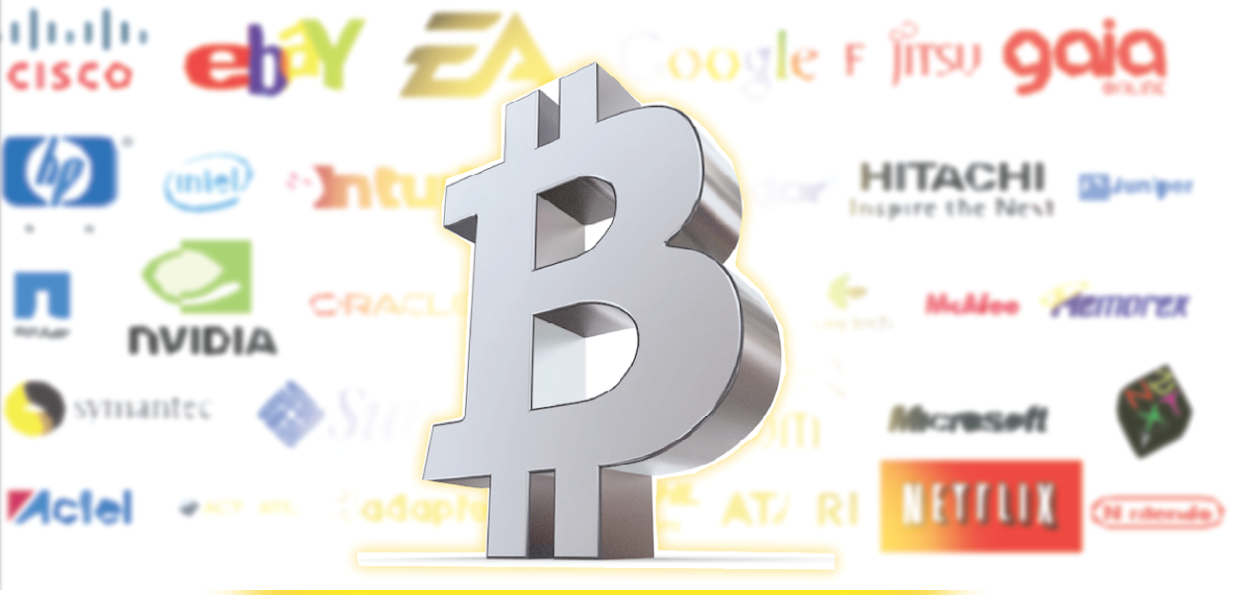

The Future of Bitcoin
So where is Bitcoin headed? Well, nobody knows for sure, but the old naysayers who would frighten investors with talk of a worthless Bitcoin a few years ago are now being heard less and less.
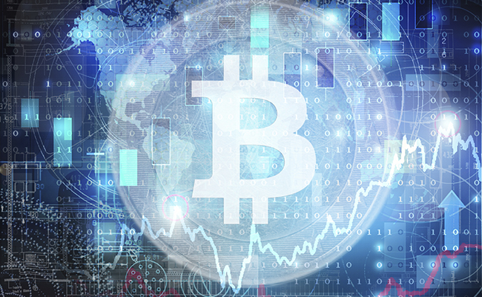
The idea of a digital currency that you yourself manage is simply too powerful. We are already eight years into this financial experiment and have only seen explosive growth in the user base.
The idea of a digital currency that you yourself manage is simply powerful. We are already eight years into this financial experiment and have only seen explosive growth in the user base.
If such growth proceeds at its present pace, then the value of a Bitcoin should rise in relation to other currencies. Eventually, we may see businesses who use Bitcoin as the base price from the outset rather than relying on other, more traditional currencies to judge its value.
In such a world, you would not have credit card companies prying into your personal data, and you would not need to set up a PayPal account. Your identity would not need to be unmasked and your data mined each time you bought a product.
One other facet of Bitcoin we have not considered is its ability to facilitate contracts.
The cryptography inherent in Bitcoin can facilitate advanced transactions, or ‘smart contracts’ as we call them. These can be written service agreements, property ownership deeds, or even death certificates. As the Bitcoin protocol advances, such documents will be able to appear within the Blockchain (as Satoshi originally intended).
But these are long-term prospects, and in the short term, Bitcoin may have to weather a few storms. There are three primary threats on the horizon that might considerably restrain, or even destroy, this new standard.
- Technical. At the moment the Bitcoin protocol copes fairly well with the tens of thousands of transactions it processes daily. However, there is doubt over Bitcoin’s ability to cope in future as this number continues to rise. This issue is known as scalability, and there is speculation on both sides of the argument. However, if the Bitcoin protocol is unable to meet the demands upon it then there will be significant doubts cast upon its future viability.

- Governmental. Since Bitcoin has a history of being used for certain taboo activities (as is cash actually), and since the Bitcoin system is inherently difficult for them to control, then governments around the world might take increased steps to control its usage. If this happens, it will clearly inhibit the Bitcoin economy considerably.
- Competition. As of now, Bitcoin remains the clear market leader among digital currencies. However, Bitcoin is not alone. Many developers have taken the open source Bitcoin code, added to it, or developed something new and launched their own cryptocurrencies. Some of the most fashionable are Ether, XRP, Litecoin and Dash. These aren’t nearly as valuable as Bitcoin at the moment. But there is always the chance that one of these currencies could overtake their parent.
So if Bitcoin can be modified for better scalability, avoid government overregulation, and beat out the competition then it is sure to remain on top. It has grown from an idea embodied in a nine-page white paper to a billion-dollar industry in less than a decade, with millions of dollars’ worth of investment capital flowing into new start-ups, and new services launched weekly.
An excellent start, and hopefully this guide has helped you get a basic grasp of this great financial experiment. But only time will prove whether Bitcoin can truly revolutionize money the way email did for communication.

Conclusion
The Bitcoin community is growing, and it is uncertain exactly how the world will react to such a massive change in the way we transact.
The Bitcoin community is growing, and it is uncertain exactly how the world will react to such a massive change in the way we transact trades.
A very interesting note to make is the fact that the supply of Bitcoins will remain constant in the future at 21,000,000 which means that as Bitcoin system becomes more used its limited supply of units will come to represent more and more USD, EUR, GBP and other currencies in the global economy. This will cause inverse inflation, simply implying that as the existing supply of Bitcoin units represent more and more good and services, the value of Bitcoin will explode in relation to its adoption.
It is certainly true that the currency could be fraught with complications but it is also true that Nakamoto has managed to come up with a decentralized system that really does represent goods or labour in the purest form.
There are some fears regarding Bitcoin Technology and some of these have valid reasons. If the Bitcoin Network becomes unreliable there may be a possibility of massive unrest during such a scenario, and it will not be restricted to only one country, region or continent, it will be global.
Many believe that if the new currency system stabalizes and meets the challenge of onboarding new customers, then we will see the decline of the US dollar standard.
Many believe that when this new currency system stabilizes and meets the challenge of gaining new users, then we will see the decline of the US dollar standard. Money should encapsulate the fair worth of anything that a free market deems so, including goods, services and labour, and Bitcoin does all of this.
But some commentators believe that this switchover from traditional money to Bitcoin could cause global instability and even mass unrest.
Others still, espouse the belief in the emergence of a secondary economy running parallel to national ones, which might make for a much more gentle transition.
Another possible future scenario may be the emergence of a second parallel global economy, one which might support global financial transactions and trade in a more versatile and safer way. It is however very difficult to predict precisely what the evolution of the cryptocurrency markets will entail in the coming decades.
But while evangelists and skeptics alike analyse data and provide their views, the Bitcoin ecosystem marches onward. All you can do is march along with it and try to make yourself successful in this new financial world.
Analysts and established financial services institutions around the world are pondering about the uncertain road forward for Bitcoins. There are several groups who approve as well as disapprove of the system for various reasons, however, as the Internet is prevalent and neutral, there really is no way of stopping or controlling the emergence of this fantastic new and fair way of dealing with money and of global trade. It simply is up to the free markets to decide if it sees Bitcoin as beneficial or not, and so far, the trend is that free markets love Bitcoin. The Bitcoin ecosystem marches onward. All you can do is march along with it and try to make yourself successful in this new world of financial. I wish you the best of success!

Glossary
The following glossary explains several Bitcoin-related terms used throughout this book.
Address (aka public key)
A Bitcoin public address, used for sending coins to, it will always begin with a 1 and appear like:
1DSrfJdB2AnWaFNgSbv3MZC2m74996JafV,
Bitcoin
The name of the cryptocurrency unit (the coin), the network and the software.
Block
A group of timestamped transactions marked with a fingerprint of the previous block. The block header is hashed for proof-of-work. Validated blocks are then added to the Blockchain via network consensus.
Blockchain
A list of valid blocks, each linking to its forerunner, all the way back to the Genesis Block.
Confirmations
A transaction validation on the Blockchain.
Difficulty
A network-wide setting that controls what proportion of computation is needed to solve proof-of-work mining equations.

Difficulty Target
A number that relates to how difficult it is to solve blocks. The lower the number the more difficult mining becomes.
Difficulty Re-targeting
A network wide reassessment of the difficulty target that happens every 2106 blocks and takes into account the hashing power of the previous 2106 blocks when calculating a new target.
Fees
A small levy charged to a sender by the network to speed up transactions. The fees are distributed back amongst miners in return for solving blocks.
Hash
A code made from a binary input.
Genesis Block
The first block ever created within the Blockchain, used to initialize the cryptocurrency.
Miner
A network computer that validates transactions in return for Bitcoins.
Network
A peer-to-peer network that processes transactions and blocks, made up of every Bitcoin node on the network.
Proof-of-work
A mathematical problem that needs computation to answer. In Bitcoin, miners need to solve an SHA-256 problem that meets a network-wide target.
Reward
A quantity of Bitcoins encased in every new block. It is given to miners as a reward for solving blocks.
Secret key (aka non-public key)
The secret numerical string that corresponds with a particular public key (address). Both need to be ‘hashed’ in order to unlock Bitcoins held in the address.
Transaction
In straightforward terms, a transfer of Bitcoins from one address to another.
Wallet
A file containing a private and public key, functioning like a cash wallet for Bitcoins.

